Contents

1. Manage Company Profiles 4

1.1 With user permission 4

1.2 With administrator permission 7

2. Manage Customers 10

2.1 List of customers 10

2.2 View customer detail 11

2.3 Add customer 13

2.4 Edit customer 15

2.5 Delete customer 17

2.6 Search customer 18

3. Manage Contacts 19

3.1 List of contacts 19

3.2 View contact detail 20

3.2.1 With no customer 20

3.2.2 With customer 22

3.3 Add contact 23

3.4 Edit contact 25

3.4.1 With no customer 25

3.4.2 With customer 28

3.5 Delete contact 30

3.6 Search contact 31

4. Manage projects 32

4.1 List of projects 33

4.2 View project detail 34

4.3 Add project 36

4.4 Edit project 39

4.5 Delete project 42

4.6 Search project 43

4.7 Manage project references 44

4.7.1 Manage tasks 44

4.7.1.1 List of tasks 44

4.7.1.2 View task detail 45

4.7.1.3 Add task 47

4.7.1.4 Edit task 48

4.7.1.5 Delete task 50

4.7.1.6 Search task 51

4.7.2 Manage bugs 52

4.7.2.1 List of bugs 52

4.7.2.2 View bug detail 53

4.7.2.3 Add bug 55

4.7.2.4 Edit bug 56

4.7.2.5 Delete bug 59

4.7.2.6 Search bug 60

4.7.3 Manage tickets 61

4.7.3.1 List of tickets 61

4.7.3.2 View ticket detail 62

4.7.3.3 Add ticket 64

4.7.3.4 Edit ticket 65

4.7.3.5 Delete ticket 68

4.7.3.6 Search ticket 70

4.7.4 Manage documents 71

4.7.4.1 List of documents 71

4.7.4.2 View document detail 71

4.7.4.3 Add document 72

4.7.4.4 Edit document 73

4.7.4.5 Delete document 76

4.7.4.6 Search document 77

|  |  |
| --- | --- |
|  | Cateno Vietnam |

MultiOrg

Manage Projects

Version 1.0.0.0

20/06/2014

Revision History

|  |  |  |  |
| --- | --- | --- | --- |
| **Name** | **Date** | **Reason For Changes** | **Version** |
| Quynh Nguyen | 20/06/2014 | Initial Document | v1.0.0.0 |
| Quynh Nguyen | 02/07/2014 | Writing manage projects | v1.0.0.0 |

# Manage Company Profiles

## With user permission

**Purpose**: managing the company profiles for user.

**Who can use this**: user.

**Description**:

* The system shows Left Navigator in webpage.
* User clicks “Company profiles” in Left Navigator.
* The system highlights “Company profiles” in Left Navigator.
* The system allows viewing the “Company profiles”.
* The system shows two tabs with “Company Information” and “Package Plan”.
* In “Company Information” tab (Name, Alias, Email, Postal address, Visiting address, Country, Fax, Org Number, Created date, Information, Name, Phone, Mobile and Email).

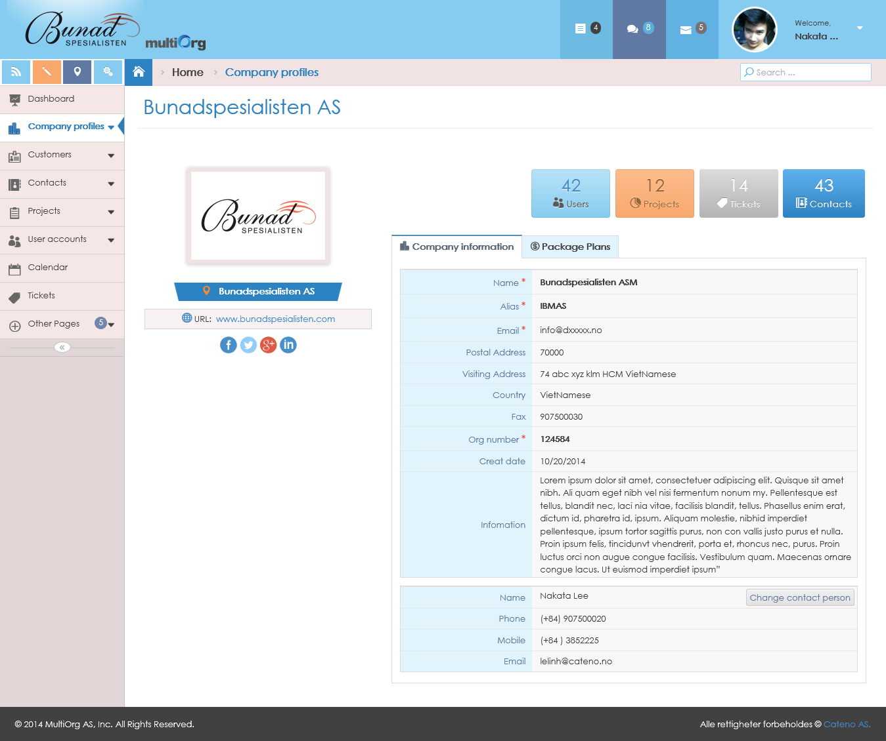

Picture: Viewing the company information tab

* In “Package Plans” tab (Package plans, User accounts, Customers, Projects and Expire date).

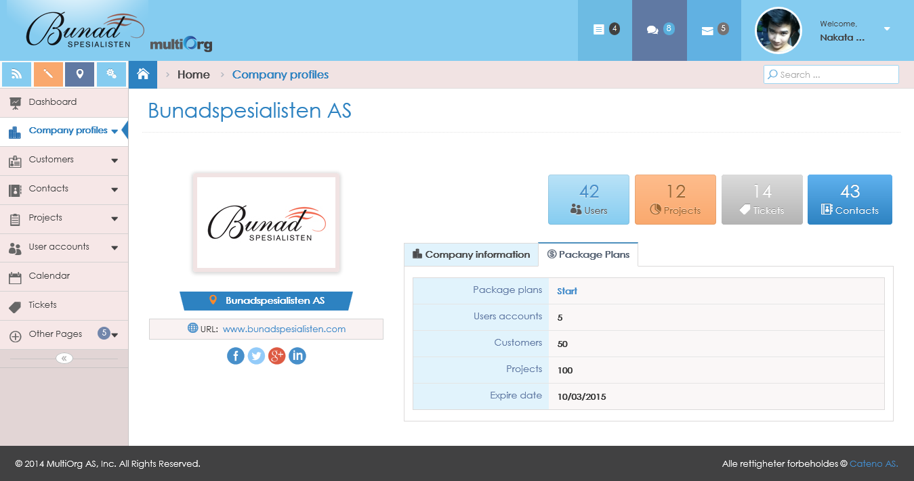

Picture: Viewing the package plans tab

* However, when Expire date is nearly expire. The system shows notification on top of per pages that sets on Setting Page.

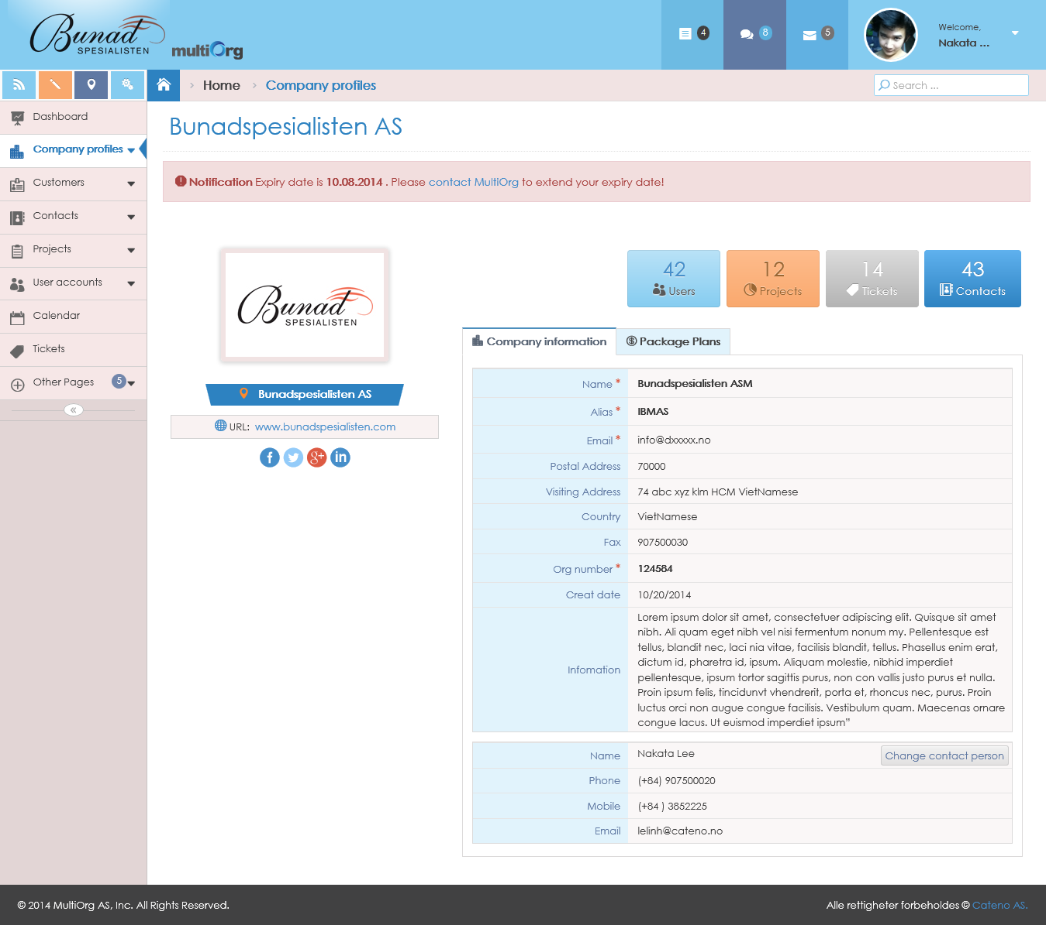

Picture: Show notification on top of page

## With administrator permission

**Purpose**: allow editing the company profiles for administrator.

**Who can use this**: administrator.

**Description**:

* The system shows Left Navigator in webpage.
* Administrator clicks “Company profiles” in Left Navigator.
* The system highlights “Company profiles” in Left Navigator.
* The system shows two tabs with “Company Information” and “Package Plans” with disable all fields.
* If administrator clicks “Edit” button, the system will enable fields to edit “Company profiles” that has “Save” and “Cancel” button.
* Administrator changes the editing information on “Company profiles”.
* In “Company Information” tab (Company Name, Alias, Company Email, Postal address, Visiting address, Country, Fax, Org Number, Created date, Information, Name, Phone, Mobile, Email, Position, Username and Password).



Picture: Editing the company information tab

* In “Package Plans” tab:
* The system allows establishing service package that customers can buy. It includes three package plans with “Basic”, “Standard”, and “Total”.
* Belongs to each package, user establishes the value with corresponding as the following:

1. The system allows creating that how many do user accounts. (Example: Package has 5 user accounts).
2. The system allows adding that how many do customers. (Example: Package has 50 customers).
3. The system allows adding that how many do projects. (Example: Package has 100 projects).
4. The system allows inputting Expire date field. If user chooses Expire date with no format with date time, the system will show validation with the message: “Please enter a date in the format!”.



Picture: Editing the package plan tab

* The system disables Org Number value in “Company Information” tab. (This can’t change this field).
* If administrator isn’t input the required fields, the system will show validation with the message: “* Required”.
* If administrator inputs incorrectly the format for email according to two fields: Company Email and Email, the system will show validation with the message: “Email invalid!”.
* If administrator clicks “Cancel” button, the system will disable fields that has “Edit” button.
* If administrator clicks “Save” button, the system will save information that validated value to database and shows the message box: “Data were saved successfully!”.
* However, if administrator wants to change the contact person information, you will click “Change contact person” button in “Company Information” tab.
* The system shows contact person page to change.
* Administrator changes the contact person information.
* Administrator clicks “Save” button.
* The system saves the contact person information to database and redirect to “Company profiles” page with new contact person information.

# Manage Customers

## List of customers

**Purpose**: show list of customers.

**Who can use this**: user.

**Description**:

* The system shows Left Navigator in webpage.
* User clicks “Customers” in Left Navigator.
* The system highlights “Customers” in Left Navigator.
* The system shows list of customers on grid with: Name, Contact info, Logo, Org number and Created date.

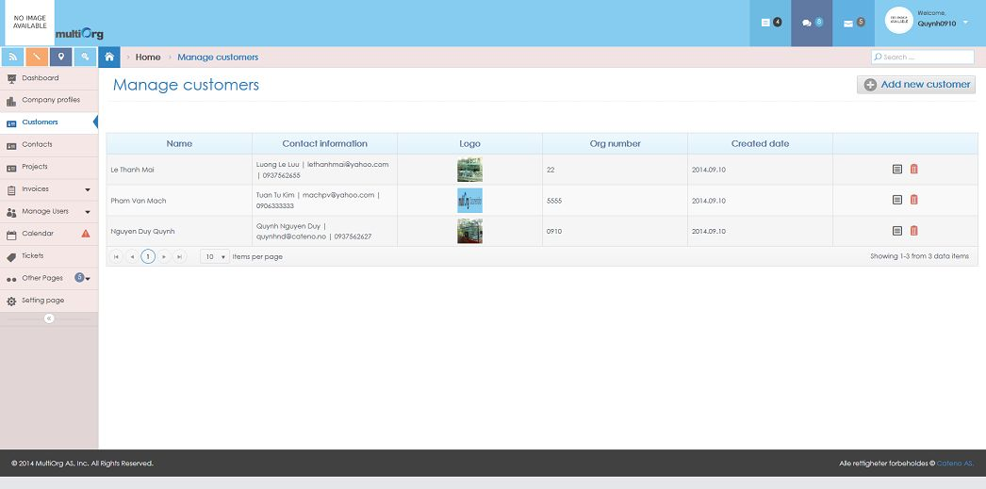

Picture: List of customers

## View customer detail

**Purpose**: support to view customer detail.

**Who can use this**: user.

**Description**:

* The system shows Left Navigator in webpage.
* User clicks “Customers” in Left Navigator.
* The system highlights “Customers” in Left Navigator.
* User clicks “View” button on grid.

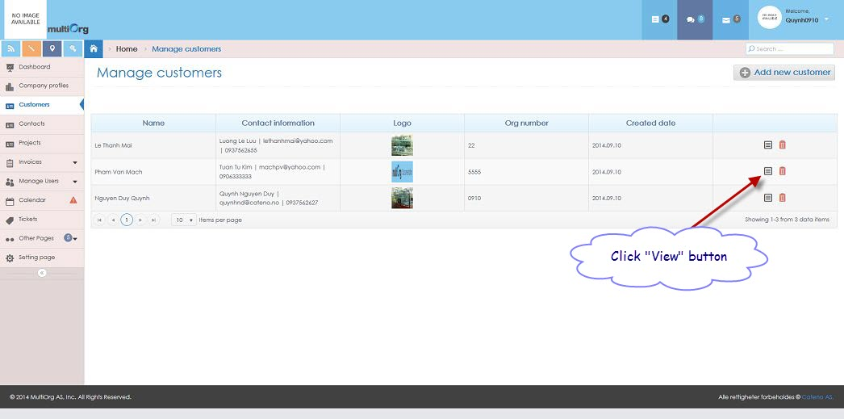

Picture: List of customers

* The system shows customer detail page.
* However, the system remains to highlight “Customers” in Left Navigator.

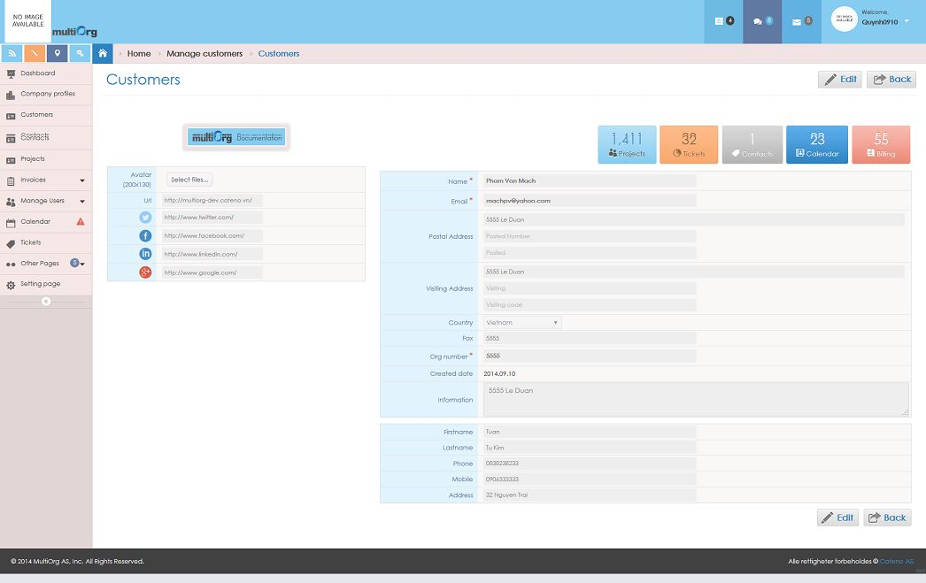

Picture: View customer detail

## Add customer

**Purpose**: allow user to add customer.

**Who can use this**: user.

**Description**:

* The system shows Left Navigator in webpage.
* User clicks “Customers” in Left Navigator.
* The system highlights “Customers” in Left Navigator.
* The system shows list of customers on grid.

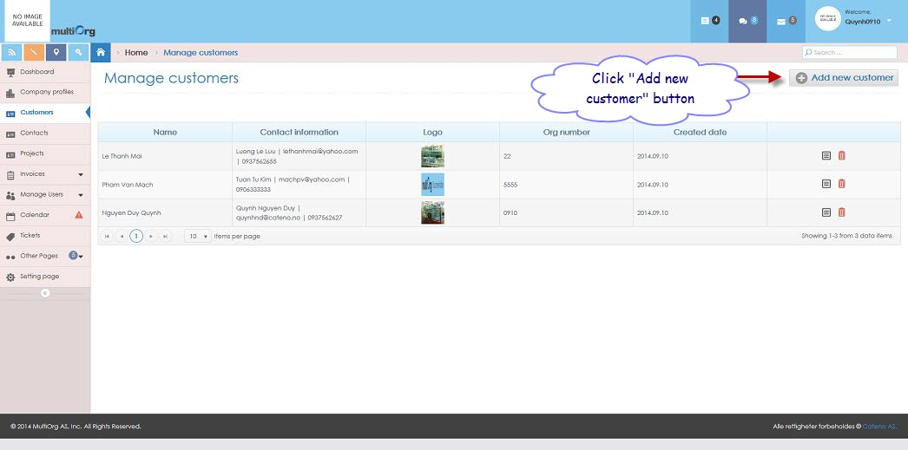

Picture: List of customers

* User clicks “Add new customer” button for adding new customer.
* The system shows “Add customer” page.
* However, the system remains to highlight “Customers” in Left Navigator.

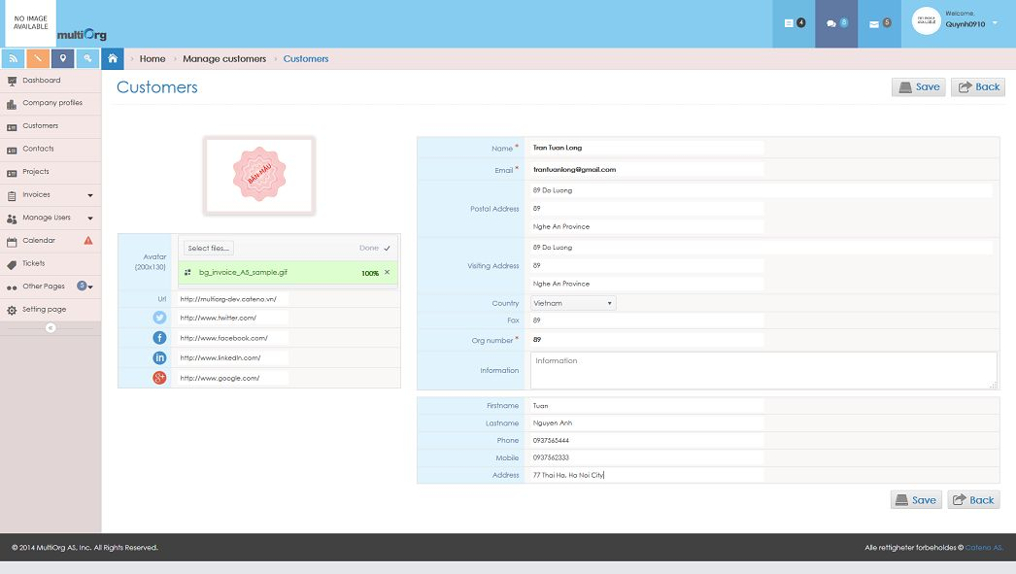

Picture: Add customer

* User inputs some fields for customer.
* If user isn’t input the required fields, the system will show validation with the message: “* Required”.
* If user inputs string value for Org number field, the system will show validation with the message: “Input value only numbers”. Only allows inputting the number.
* If user inputs incorrectly the format for email according to Email field, the system will show validation with the message: “Email invalid!”.
* If user clicks “Cancel” button, the system will return to list of customers.
* If user clicks “Save” button, the system will check unique value with Org number from database.
* If Org number existed in database, the system would show the message: “Org number existed. Please input other value for Org number.”
* If Org number didn’t exist in database, the system would allow getting current Org number.
* The system saves information that validated value to database and shows the message box: “Data were saved successfully!”.

## Edit customer

**Purpose**: allow user to edit customer.

**Who can use this**: user.

**Description**:

* The system shows Left Navigator in webpage.
* User clicks “Customers” in Left Navigator.
* The system highlights “Customers” in Left Navigator.
* The system shows list of customers on grid.
* User clicks “View” button on grid.



Picture: List of customers

* The system shows customer detail page with disable all fields.
* However, the system remains to highlight “Customers” in Left Navigator.
* If user clicks “Back” button on customer detail page, the system will return to list of customers.
* If user clicks “Edit” button on customer detail page, the system will enable fields to edit customer that has “Save” and “Cancel” button.



Picture: View customer detail

* The system disables Org Number value. (This can’t change this field).

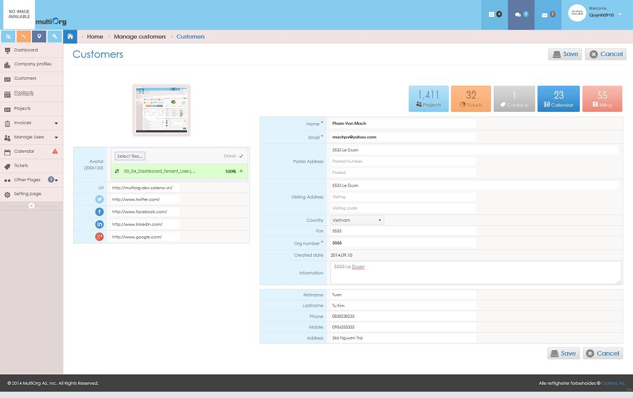

Picture: Edit customer

* User can change the data information.
* If user isn’t input the required fields, the system will show validation with the message: “* Required”.
* If user inputs incorrectly the format for email according to Email field, the system will show validation with the message: “Email invalid!”.
* If user clicks “Cancel” button, the system will disable fields that has “Edit” and “Back” button.
* If user clicks “Save” button, the system will save information that validated value to database and shows the message box: “Data were saved successfully!”.

## Delete customer

**Purpose**: allow user to delete customer.

**Who can use this**: user.

**Description**:

* The system shows Left Navigator in webpage.
* User clicks “Customers” in Left Navigator.
* The system highlights “Customers” in Left Navigator.
* The system shows list of customers on grid.

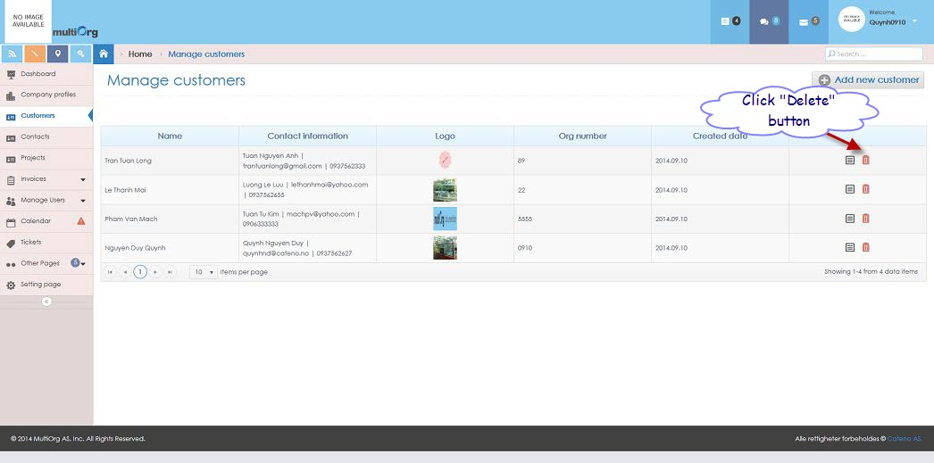

Picture: List of customers

* User clicks “Delete” button on grid.
* The system shows the message box: “Do you want to delete this data?”.
* If user clicks “No” button, the system won’t delete the customer and returns to list of customers.
* If user clicks “Yes” button, the system will delete the customer and returns to list of updated customers.

## Search customer

**Purpose**: support to search customer.

**Who can use this**: user.

**Description**:

* The system shows Left Navigator in webpage.
* User clicks “Customers” in Left Navigator.
* The system highlights “Customers” in Left Navigator.
* User inputs data with condition fields of customer or chooses data from list showing to search.
* The system shows list of search customers based on conditions.

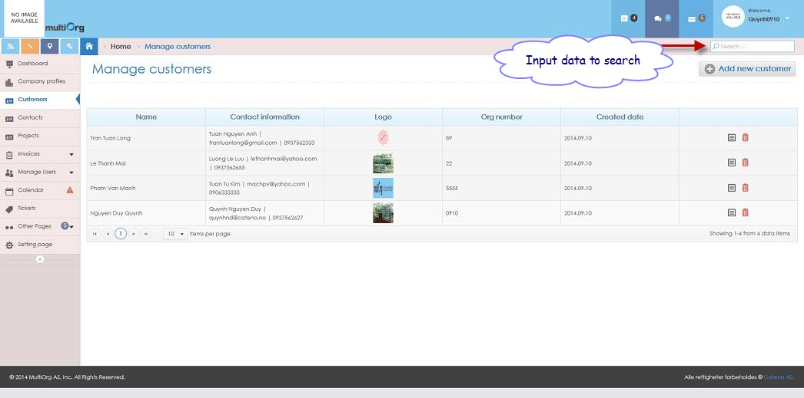

Picture: Search customer

# Manage Contacts

## List of contacts

**Purpose**: show list of contacts.

**Who can use this**: user.

**Description**:

* The system shows Left Navigator in webpage.
* User clicks “Contacts” in Left Navigator.
* The system highlights “Contacts” in Left Navigator.
* The system shows list of contacts on grid.

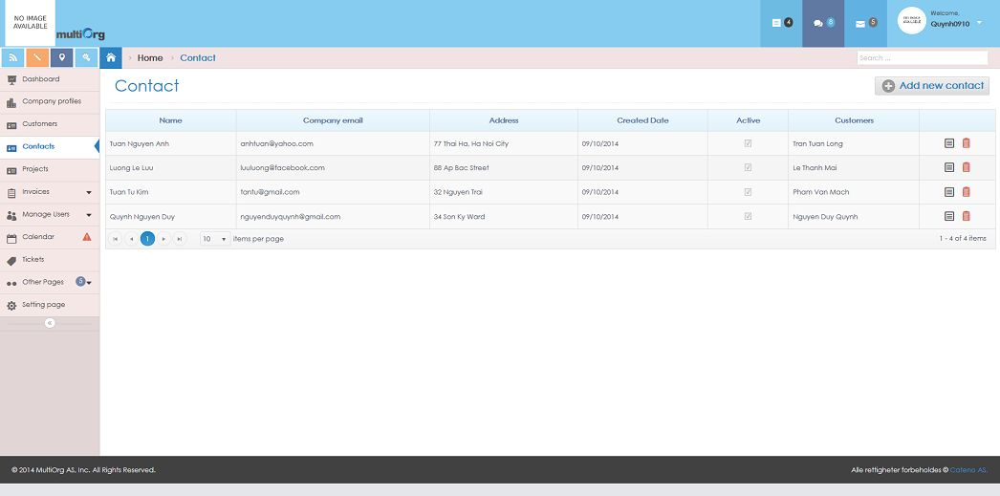

Picture: List of contacts

## View contact detail

### 3.2.1 With no customer

**Purpose**: support to view contact detail with no customer.

**Who can use this**: user.

**Description**:

* The system shows Left Navigator in webpage.
* User clicks “Contacts” in Left Navigator.
* The system highlights “Contacts” in Left Navigator.
* User clicks “View” button on grid with no customer.

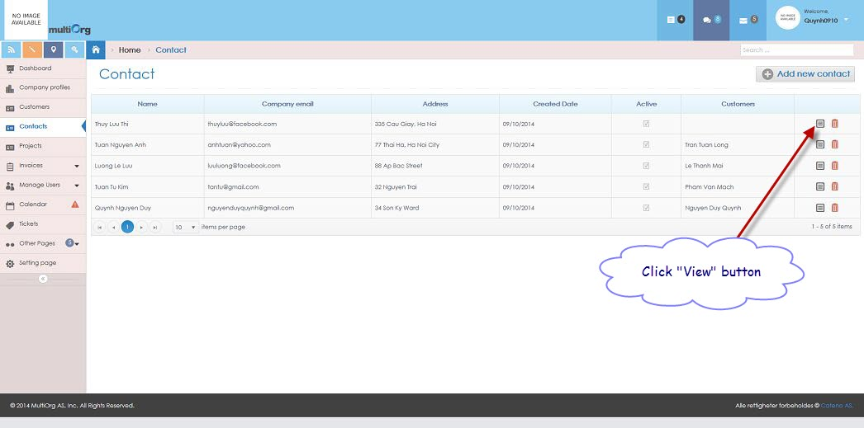

Picture: List of contacts

* The system shows contact detail with no customer page.
* However, the system remains to highlight “Contacts” in Left Navigator.

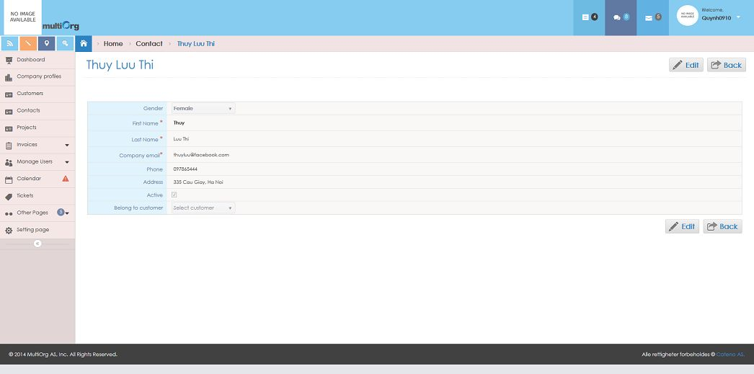

Picture: View contact detail with no customer

### 3.2.2 With customer

**Purpose**: support to view contact detail with customer.

**Who can use this**: user.

**Description**:

* The system shows Left Navigator in webpage.
* User clicks “Contacts” in Left Navigator.
* The system highlights “Contacts” in Left Navigator.
* User clicks “View” button on grid with customer.

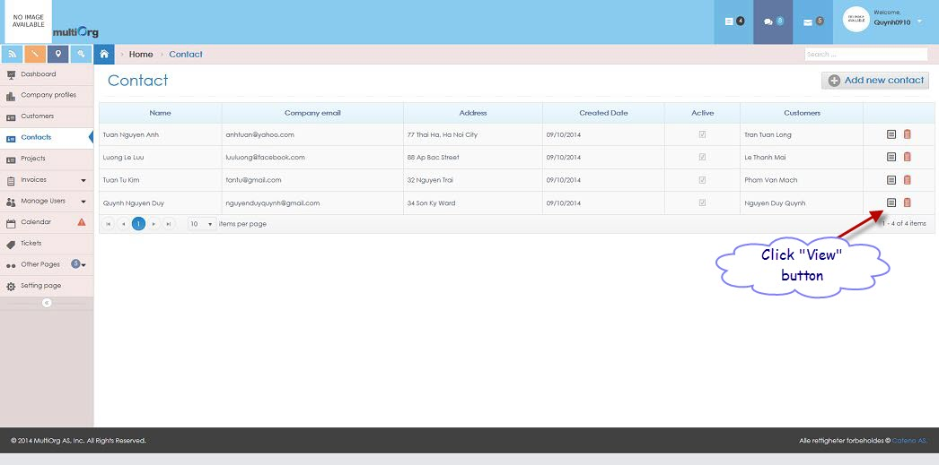

Picture: List of customers

* The system shows contact detail with customer page.
* However, the system remains to highlight “Contacts” in Left Navigator.

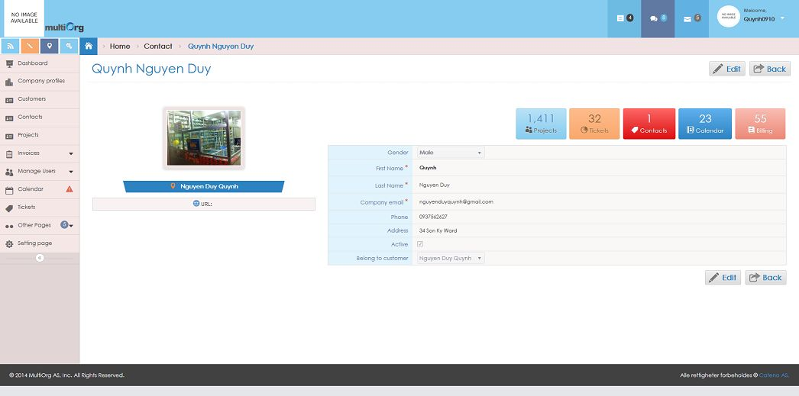

Picture: View contact detail with customer

* However, if user clicks “customer” button (Example: current customer: “Nguyen Duy Quynh” or the URL link: <http://multiorg.cateno.vn/Quynhnd0910>, the system will show the main Dashboard.

## Add contact

**Purpose**: allow user to add contact.

**Who can use this**: user.

**Description**:

* The system shows Left Navigator in webpage.
* User clicks “Contacts” in Left Navigator.
* The system highlights “Contacts” in Left Navigator.
* The system shows list of contacts on grid.

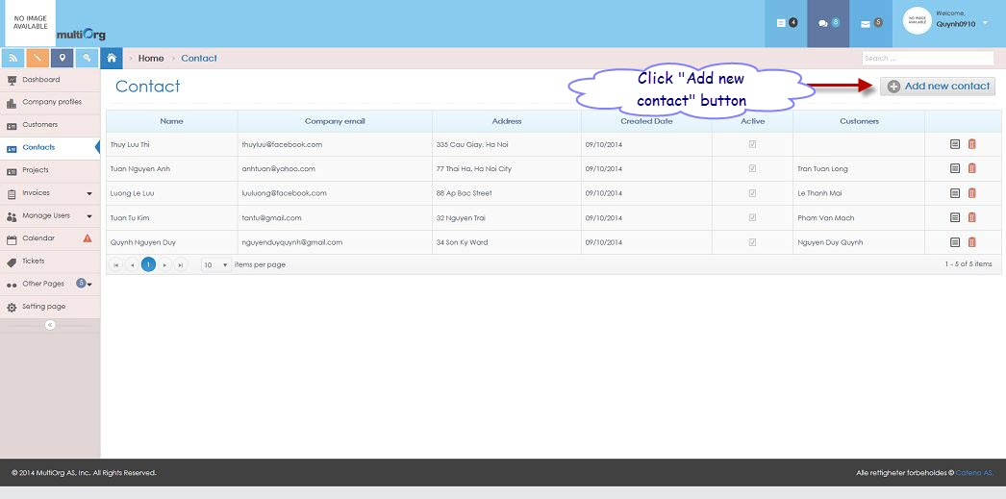

Picture: List of contacts

* User clicks “Add new contact” button for adding new contact.
* The system shows “Add contact” page.
* However, the system remains to highlight “Contacts” in Left Navigator.

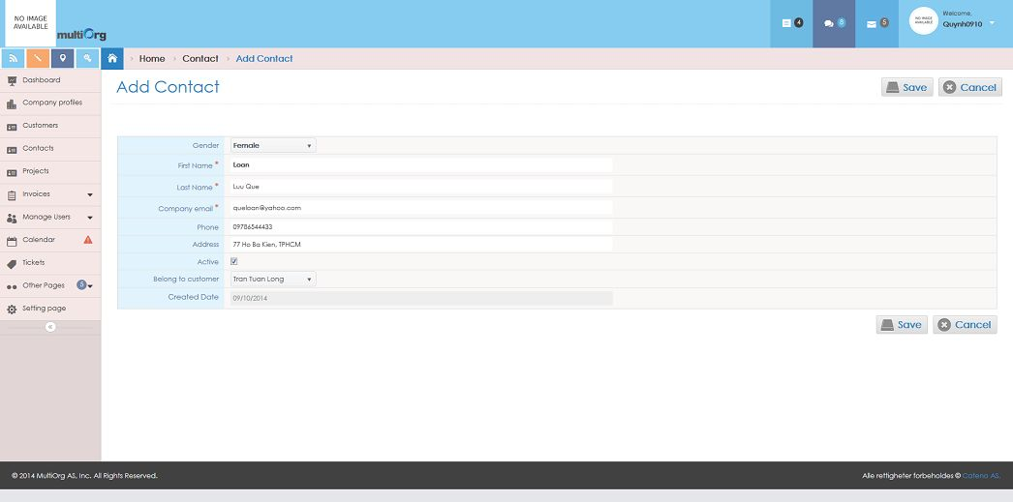

Picture: Add contact

* User inputs some fields for contact.
* If user isn’t input the required fields, the system will show validation with the message: “* Required”.
* If user inputs incorrectly the format for email according to Email field, the system will show validation with the message: “Email invalid!”.
* User chooses customer from list.
* If user clicks “Cancel” button, the system will return to list of contacts.
* If user clicks “Add” button, the system will save information that validated value to database and shows the message box: “Data were saved successfully!”.

## Edit contact

### 3.4.1 With no customer

**Purpose**: allow user to edit contact with no customer.

**Who can use this**: user.

**Description**:

* The system shows Left Navigator in webpage.
* User clicks “Contacts” in Left Navigator.
* The system highlights “Contacts” in Left Navigator.
* The system shows list of contacts on grid.
* User clicks “View” button on grid with no customer.



Picture: List of contacts

* The system shows contact detail page with disable all fields.
* However, the system remains to highlight “Contacts” in Left Navigator.



Picture: View contact detail

* If user clicks “Back” button on contact detail page, the system will return to list of contacts.
* If user clicks “Edit” button on contact detail page with no customer, the system will enable fields to edit contact with no customer page that has “Save” and “Cancel” button.

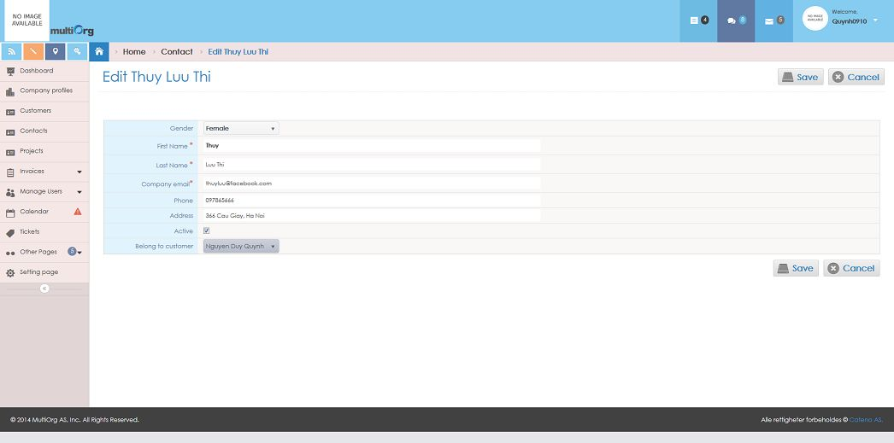

Picture: Edit contact with no customer

* User can change the data information.
* If user isn’t input the required fields, the system will show validation with the message: “* Required”.
* If user inputs incorrectly the format for email according to Email field, the system will show validation with the message: “Email invalid!”.
* User chooses customer from list.
* If user clicks “Cancel” button, the system will disable fields that has “Edit” and “Back” button.
* If user clicks “Save” button, the system will save information that validated value to database and shows the message box: “Data were saved successfully!”.

### 3.4.2 With customer

**Purpose**: allow user to edit contact with customer.

**Who can use this**: user.

**Description**:

* The system shows Left Navigator in webpage.
* User clicks “Contacts” in Left Navigator.
* The system highlights “Contacts” in Left Navigator.
* The system shows list of contacts on grid.
* User clicks “View” button on grid with customer.



Picture: List of contacts

* The system shows contact detail page with disable all fields.



Picture: View contact detail

* However, if user clicks “customer” button (Example: current customer: “Nguyen Duy Quynh” or the URL link: <http://multiorg.cateno.vn/Quynhnd0910>, the system will show the main Dashboard.
* If user clicks “Back” button on contact detail page, the system will return to list of contacts.
* If user clicks “Edit” button on contact detail page with customer, the system will enable fields to edit contact with customer page that has “Save” and “Cancel” button.

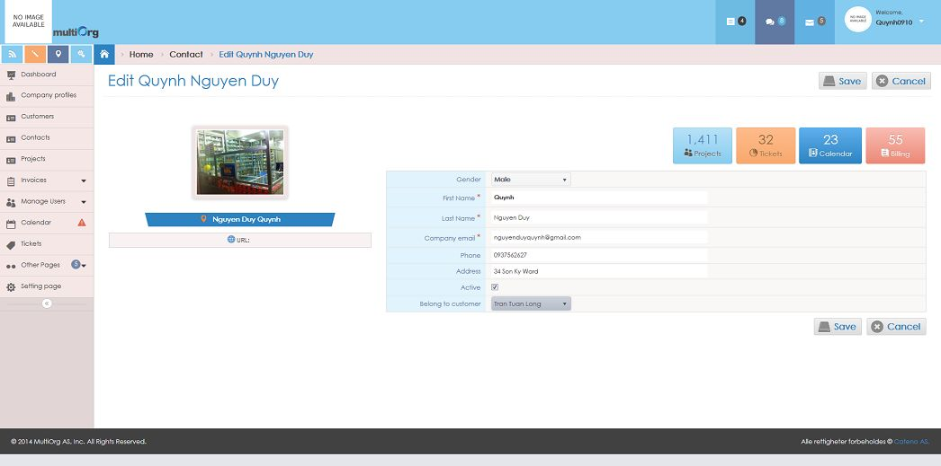

Picture: Edit contact with customer

* User can change the data information.
* If user isn’t input the required fields, the system will show validation with the message: “* Required”.
* If user inputs incorrectly the format for email according to Email field, the system will show validation with the message: “Email invalid!”.
* User chooses customer from list.
* If user clicks “Cancel” button, the system will disable fields that has “Edit” and “Back” button.
* If user clicks “Save” button, the system will save information that validated value to database and shows the message box: “Data were saved successfully!”.

## Delete contact

**Purpose**: allow user to delete contact.

**Who can use this**: only user who created the contact.

**Description**:

* The system shows Left Navigator in webpage.
* User clicks “Contacts” in Left Navigator.
* The system highlights “Contacts” in Left Navigator.
* The system shows list of contacts on grid.

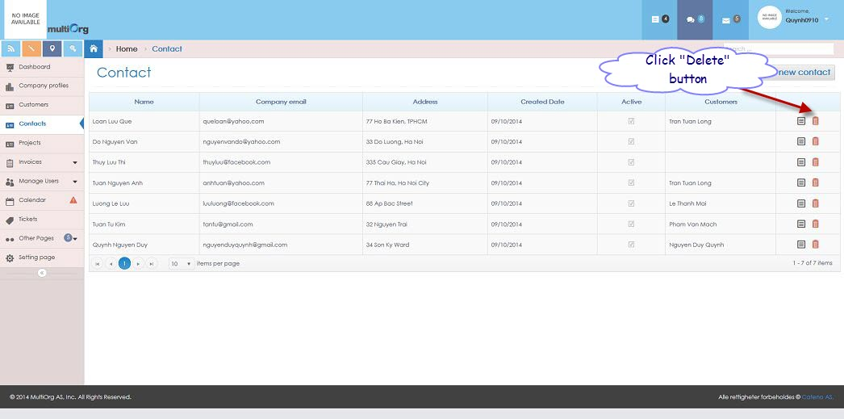

Picture: List of contacts

* User clicks “Delete” button on grid.
* The system shows the message box: “Do you want to delete this data?”.
* If user clicks “No” button, the system won’t delete the contact and returns to list of contacts.
* If user clicks “Yes” button, the system will delete the contact and returns to list of updated contacts.

## Search contact

**Purpose**: support to search contact.

**Who can use this**: user.

**Description**:

* The system shows Left Navigator in webpage.
* User clicks “Contacts” in Left Navigator.
* The system highlights “Contacts” in Left Navigator.
* User inputs data with condition fields of contact or chooses data from list showing to search.
* The system shows list of search contacts based on conditions.

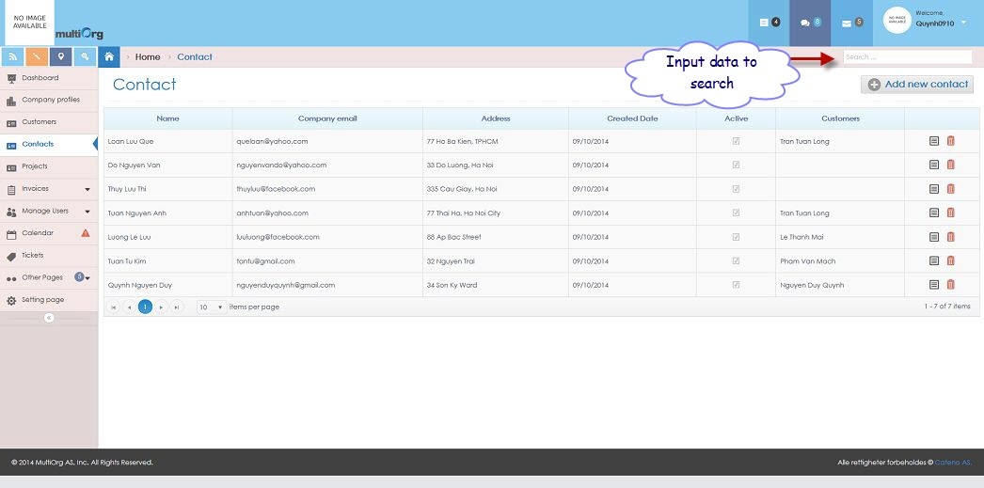

Picture: Search contact

# Manage projects

**Purpose**: creating the projects for user.

**Who can use this**: user.

**Description**:

* Administrator creates the project or some people in company to create it.
* When creating the project, object customer must assign to the project.
* One customer can have multiple projects.
* The project has some relative information:
* Tasks
* Bugs
* Tickets
* Documents
* The system allows customer upload or download documents.
* The project must have contacts information.
* However, the system shares documents for customer and administrator.
* Besides, tasks have some information: name, status, resolution, complete date, due date, assign to, and description.
* Besides, bugs have some information: name, status, resolution, complete date, due date, assign to, attachment folder, and description.
* Besides, tickets have some information: ticket number, ticket name, status, resolution, complete date, due date, assign to, attach file, and description.
* Besides, documents have some information: document name, attach file, created date, comment and owner.
* Besides, contacts of customer have some information: gender, name, email, phone, address and active.

## List of projects

**Purpose**: show list of projects.

**Who can use this**: user.

**Description**:

* User clicks “Projects” in Left Navigator.
* The system highlights “Projects” in Left Navigator.
* The system shows list of projects on grid with:
* Code
* Name
* Status
* Contacts
* Customers
* Created date

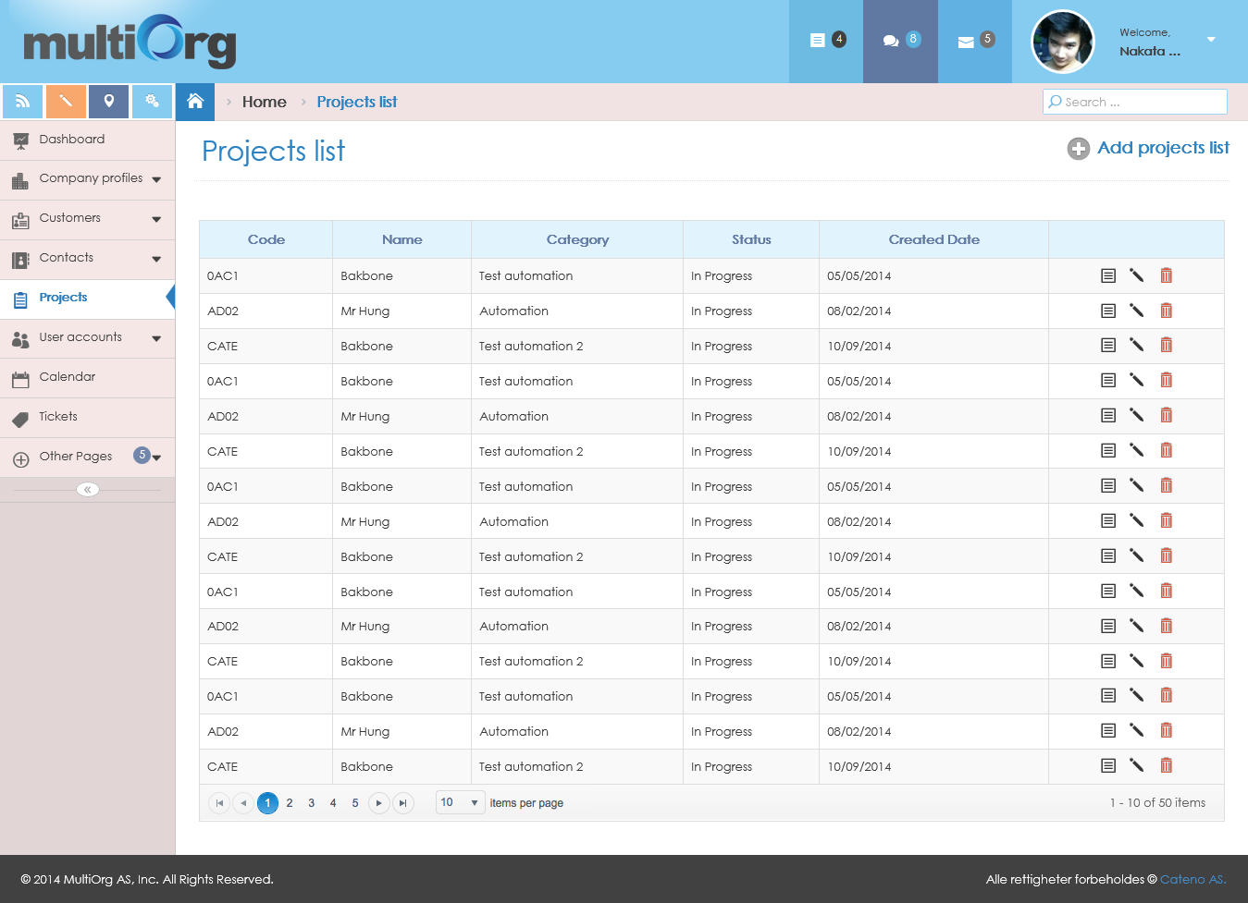

Picture: List of projects

## View project detail

**Purpose**: support to view project detail.

**Who can use this**: user.

**Description**:

* User clicks “Projects” in Left Navigator.
* The system highlights “Projects” in Left Navigator.
* The system shows list of projects on grid.
* User clicks “View” button on grid.

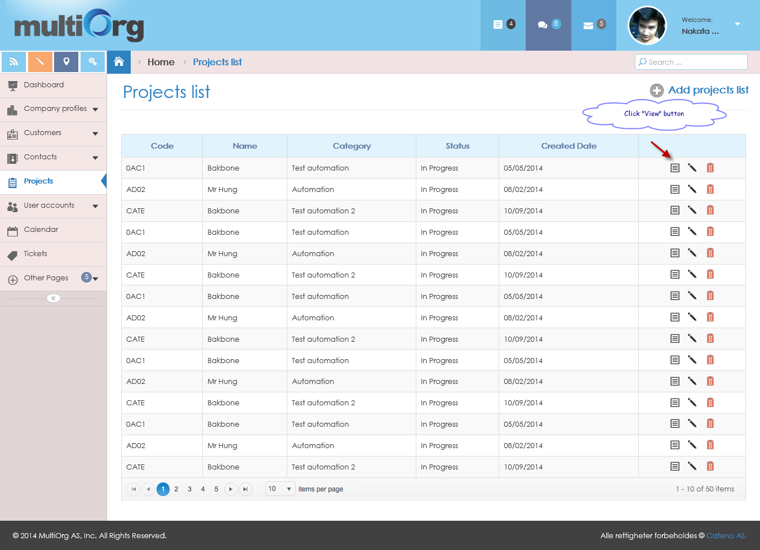

Picture: List of projects

* The system shows project detail with information:
* Code
* Name
* Description
* Category
* Project Lead
* Permission
* Status
* Started Date
* Completed Date
* However, the system remains to highlight “Projects” in Left Navigator.

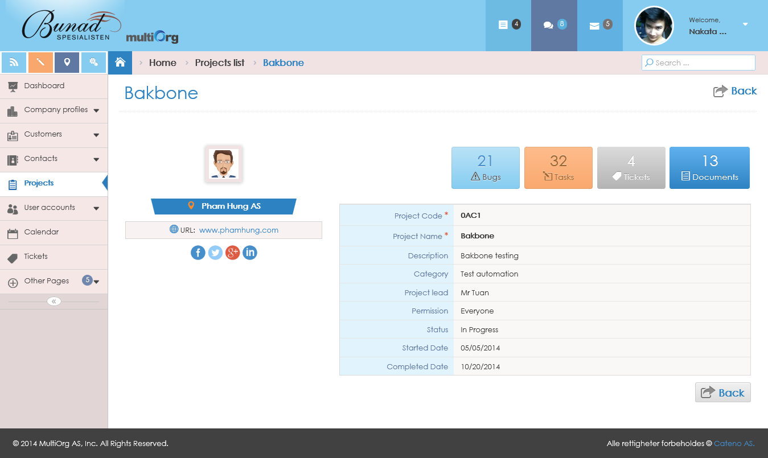

Picture: View project detail

## Add project

**Purpose**: allow user to add project.

**Who can use this**: user.

**Description**:

* User clicks “Projects” in Left Navigator.
* The system highlights “Projects” in Left Navigator.
* The system shows list of projects on grid.
* User clicks “Add new project” button for adding new project.
* However, the system remains to highlight “Projects” in Left Navigator.
* User inputs some fields for project.
* If user isn’t input the required fields, the system will show validation with the message: “* Required”.
* If user chooses Started Date and Completed Date with no format with date time, the system will show validation with the message: “Please enter a date in the format!”.
* However, the project code defines four characters with upper case.
* If user clicks “Cancel” button, the system will return to list of projects.
* If user clicks “Save and Continue” button, the system will check unique value with project code from database.
* If project code existed in database, the system would show the message: “Project Code existed. Please input other value for Project Code.”
* If project code didn’t exist in database, the system would allow getting current project code.
* The system saves information that validated value to database.

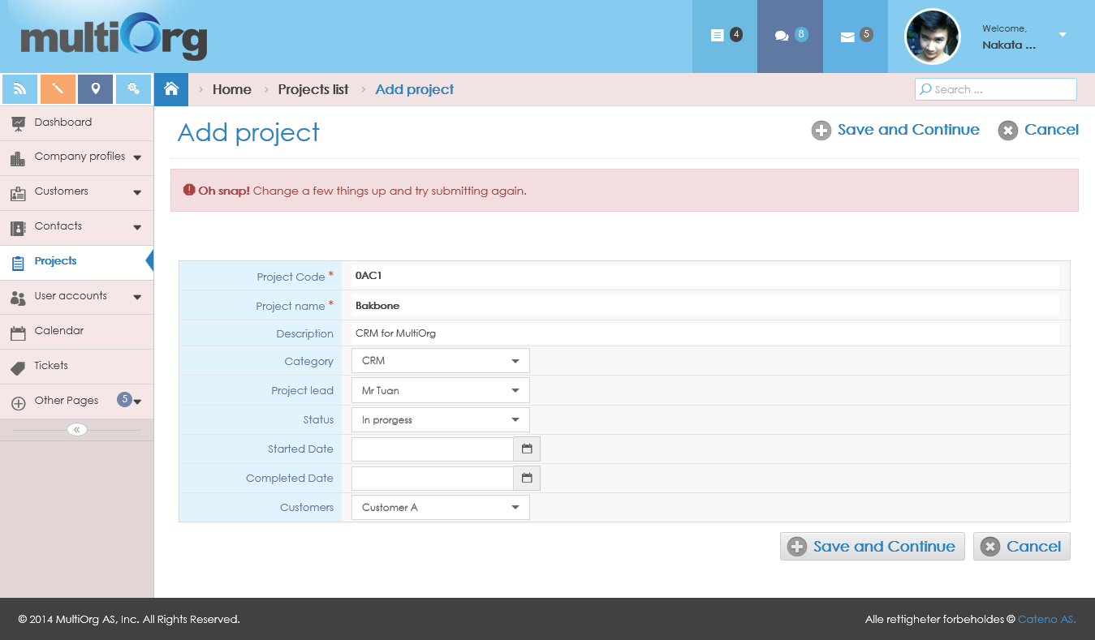

Picture: Add project

* And show “Permission” page to choose Permission setting.
* However, the system remains to highlight “Projects” in Left Navigator.

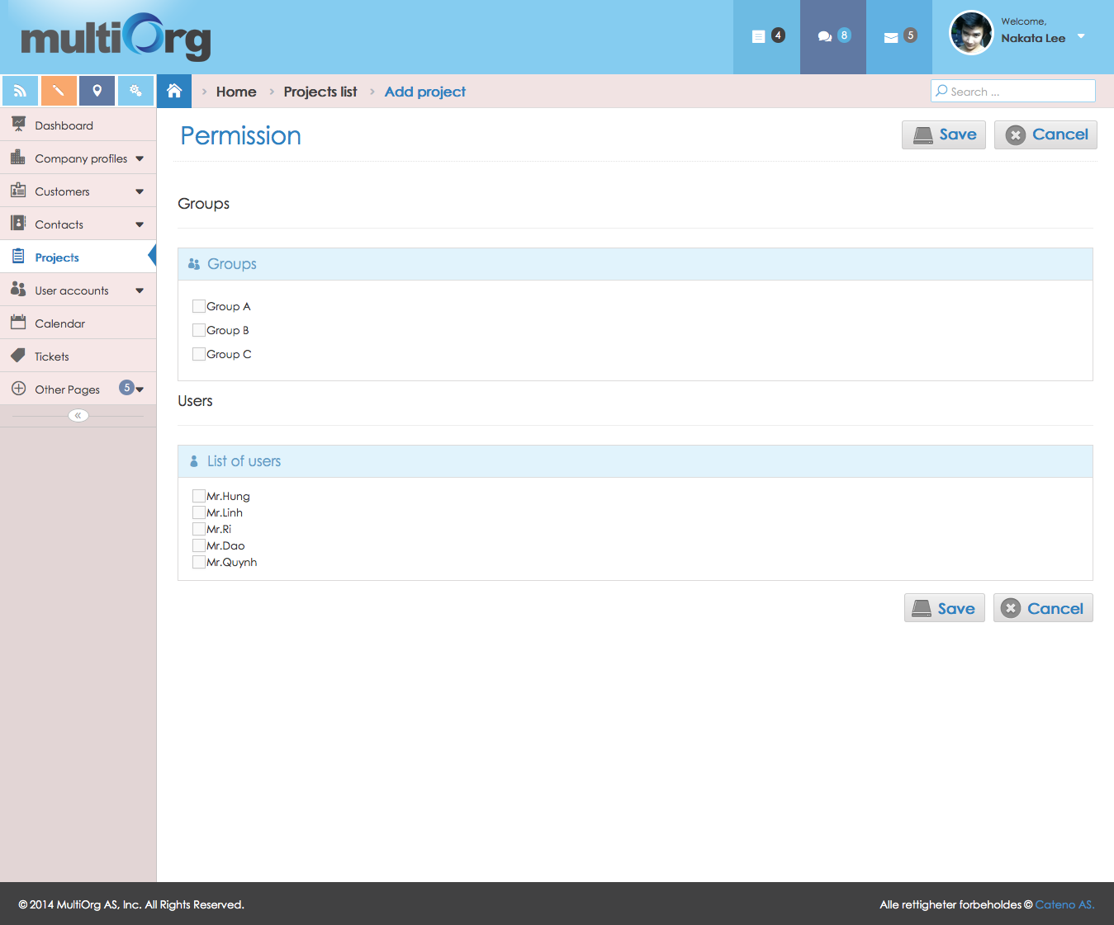

Picture: Choose permission setting

* User clicks checkbox values on “Groups” to choose.
* The system shows “List of users” belongs to above “Groups”.
* User clicks checkbox values on “Users” to choose.
* If user clicks “Cancel” button, the system will return to list of projects.
* If user clicks “Save” button, the system will save information that validated value to database and shows the message box: “Data were saved successfully!”.

## Edit project

**Purpose**: allow user to edit project.

**Who can use this**: user.

**Description**:

* User clicks “Projects” in Left Navigator.
* The system highlights “Projects” in Left Navigator.
* The system shows list of projects on grid.
* User clicks “View” button on grid.



Picture: List of projects

* The system shows project detail page with disable all fields.
* However, the system remains to highlight “Projects” in Left Navigator.



Picture: View project detail

* If user clicks “Back” button on project detail page, the system will return to list of projects.
* If user clicks “Edit” button on project detail page, the system will enable fields to edit project that has “Save” and “Cancel” button.
* User changes some fields for project.
* If user isn’t input the required fields, the system will show validation with the message: “* Required”.
* If user chooses Started Date and Completed Date with no format with date time, the system will show validation with the message: “Please enter a date in the format!”.
* However, the Project Code defines four characters with upper case.
* The system disables Project Code value. (This can’t change this field).
* If user clicks “Cancel” button, the system will disable fields that has “Edit” and “Back” button.
* If user clicks “Save” button, the system will save information that validated value to database and shows the message box: “Data were saved successfully!”.

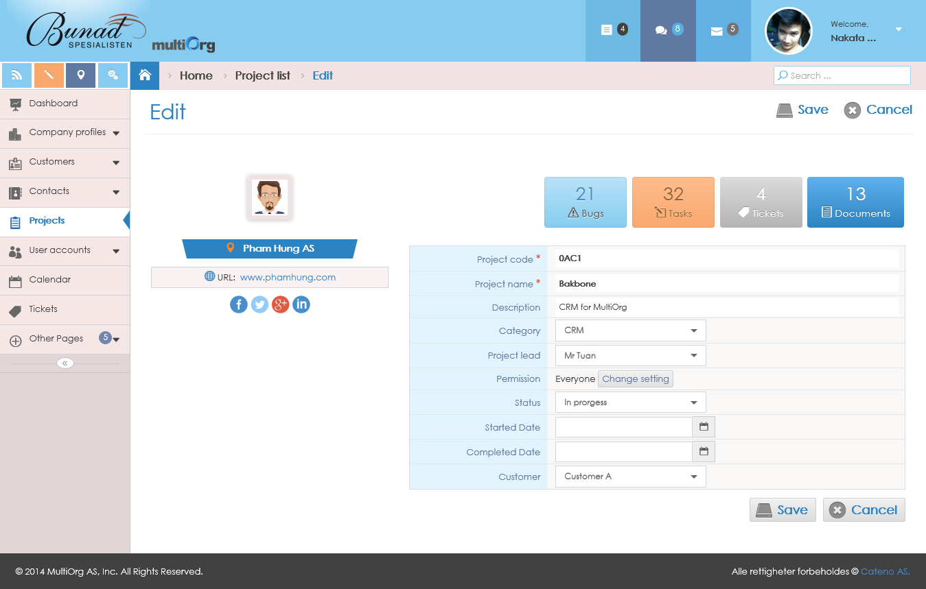

Picture: Edit project

* However, user can click “Change setting” button to edit Permission.
* The system shows “Permission” page to choose Permission setting.
* However, the system remains to highlight “Projects” in Left Navigator.
* User clicks checkbox values on “Groups” to choose.
* The system shows “List of users” belongs to above “Groups”.
* User clicks checkbox values on “Users” to choose.
* If user clicks “Cancel” button, the system will return to “Edit” page.
* If user clicks “Save” button, the system will save information that validated value to database and returns to “Edit” page with new value for Permission field.



Picture: Choose permission setting

## Delete project

**Purpose**: allow user to delete project.

**Who can use this**: only user who created the project.

**Description**:

* User clicks “Projects” in Left Navigator.
* The system highlights “Projects” in Left Navigator.
* The system shows list of projects on grid.

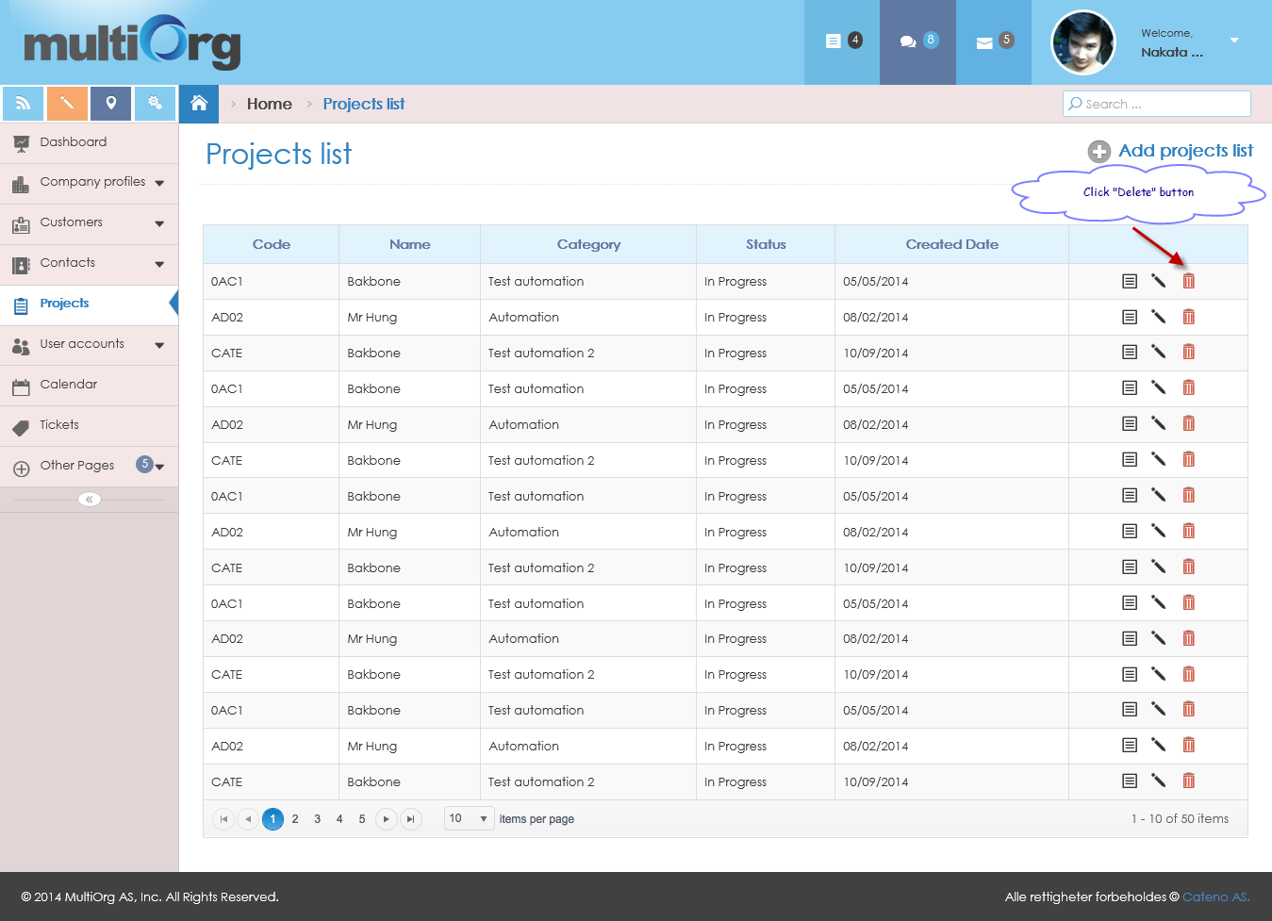

Picture: List of projects

* User clicks “Delete” button on grid.
* The system shows the message box: “Do you want to delete this data?”.
* If user clicks “No” button, the system won’t delete the project and returns to list of projects.
* If user clicks “Yes” button, the system will delete the project and returns to list of updated projects.

## Search project

**Purpose**: allow user to search project.

**Who can use this**: user.

**Description**:

* User clicks “Projects” in Left Navigator.
* The system highlights “Projects” in Left Navigator.
* The system shows list of projects on grid.
* User inputs data with condition fields of project or chooses data from list showing to search.
* The system shows list of search projects based on conditions.

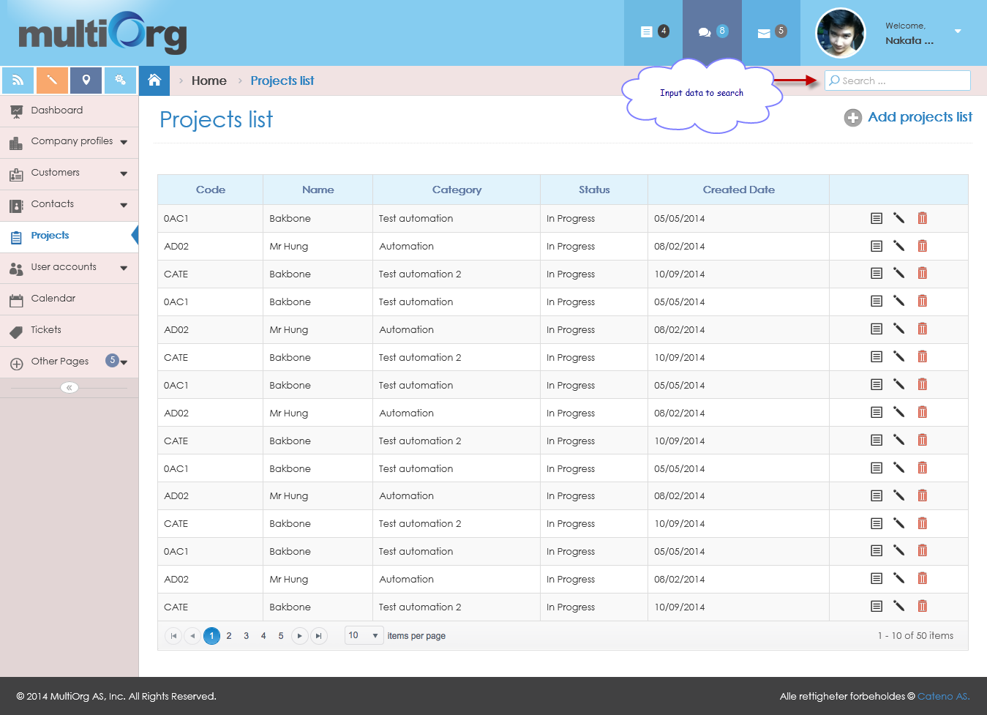

Picture: Search project

## Manage project references

### Manage tasks

#### List of tasks

**Purpose**: support to show list of tasks.

**Who can use this**: user.

**Description**:

* User clicks “Tasks” button in “Projects”.
* The system highlights “Tasks” button with “Red” color.
* The system shows list of tasks on grid.

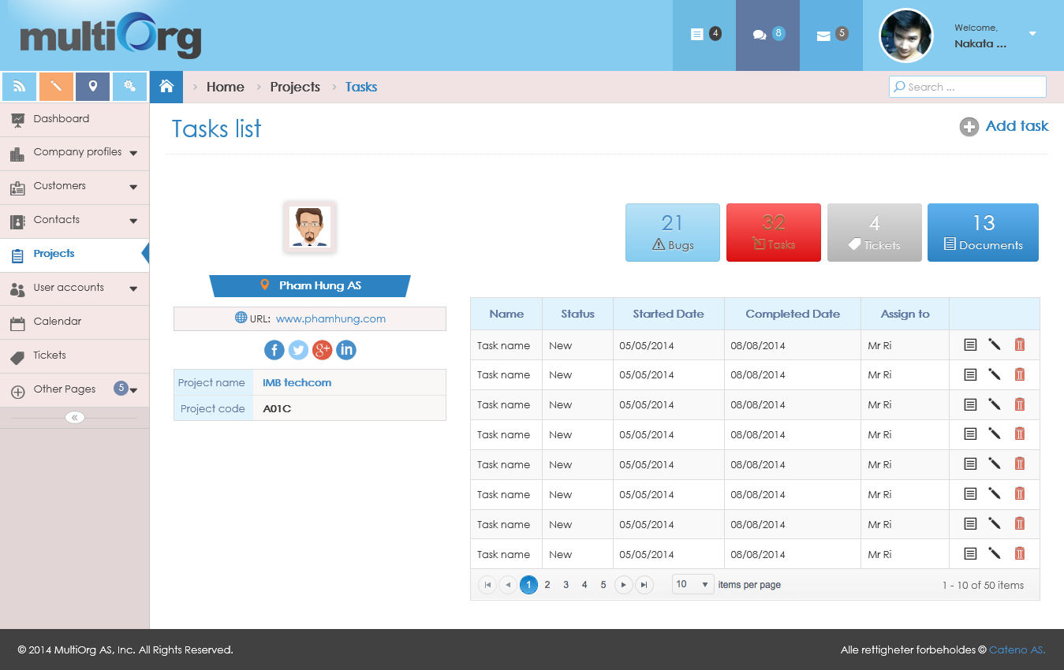

Picture: List of tasks

#### View task detail

**Purpose**: support to view task belongs to project.

**Who can use this**: user.

**Description**:

* User clicks “Tasks” button in “Projects”.
* The system highlights “Tasks” button with “Red” color.
* The system shows list of tasks on grid.
* User clicks “View” button on grid.

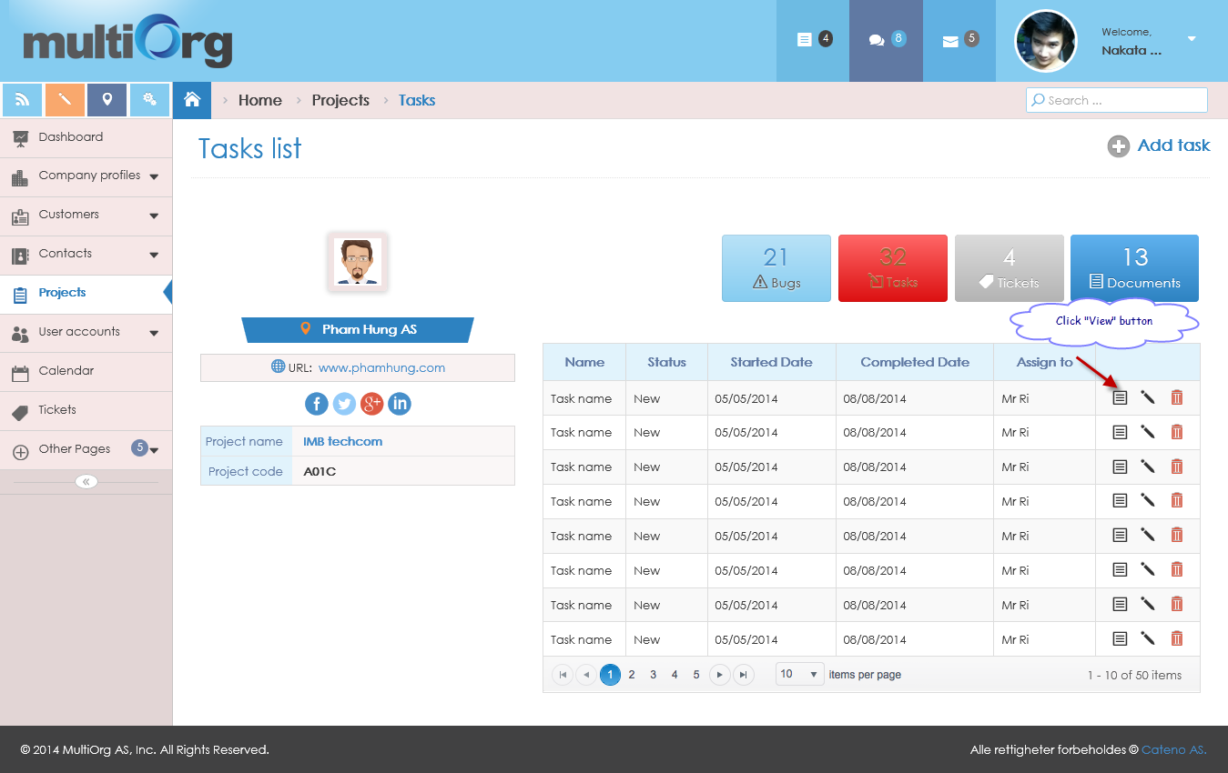

Picture: List of tasks

* The system shows task detail belongs to project.

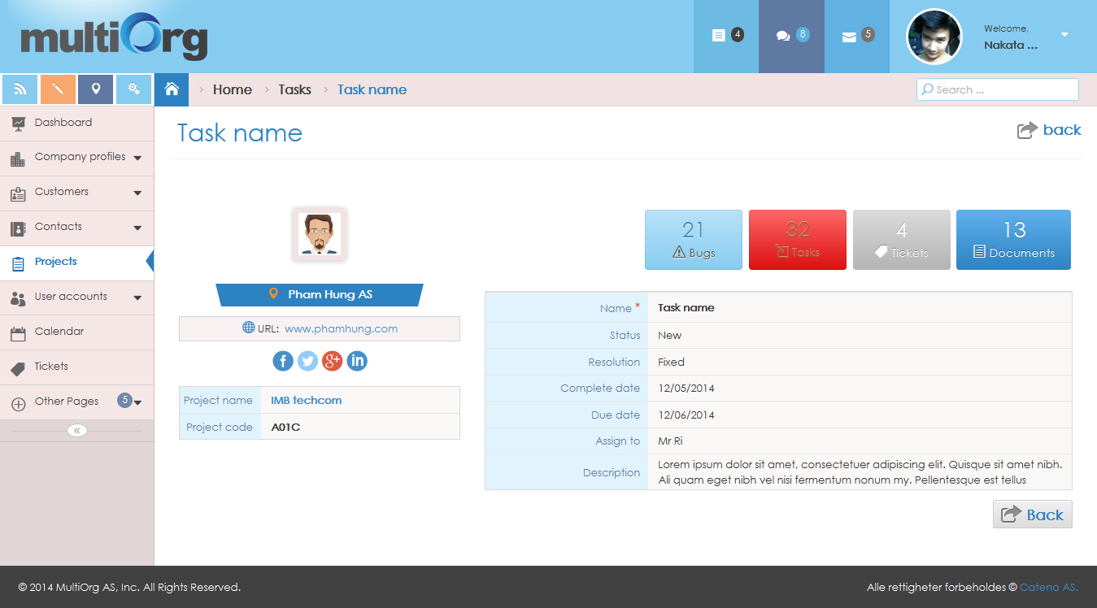

Picture: View task detail

#### Add task

**Purpose**: support to add task.

**Who can use this**: user.

**Description**:

* User clicks “Tasks” button in “Projects”.
* The system highlights “Tasks” button with “Red” color.
* The system shows list of tasks on grid.
* User clicks “Add task” button.
* The system shows the add task page.
* User inputs data of task for adding.
* If user isn’t input the required fields, the system will show validation with the message: “* Required”.
* If user chooses Started Date, Completed Date, and Due Date with no format with date time, the system will show validation with the message: “Please enter a date in the format!”.
* If user clicks “Cancel” button, the system will return to list of tasks.
* If user clicks “Save” button, the system will save data of task to database and shows the message box: “Data were saved successfully!”.

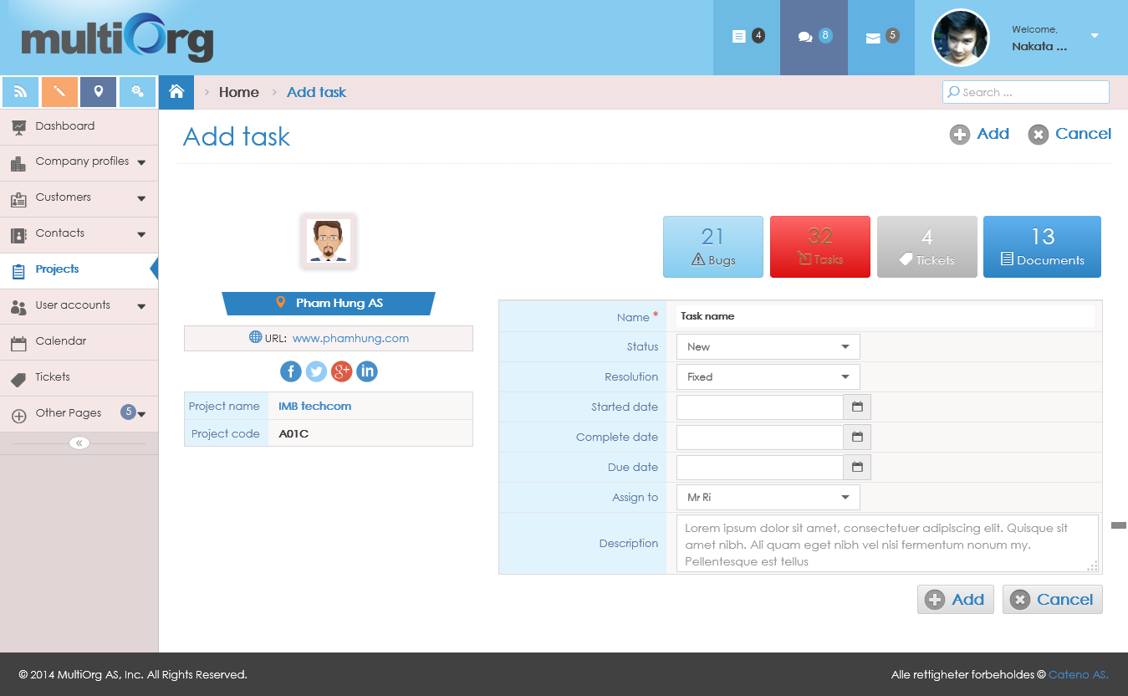

Picture: Add task

#### Edit task

**Purpose**: support to edit task belongs to project.

**Who can use this**: user.

**Description**:

* User clicks “Tasks” button in “Projects”.
* The system highlights “Tasks” button with “Red” color.
* The system shows list of tasks on grid.
* User clicks “View” button on grid.



Picture: List of tasks.

* The system shows task detail page with disable all fields.



Picture: View task detail

* If user clicks “Back” button on task detail page, the system will return to list of tasks.
* If user clicks “Edit” button on task detail page, the system will enable fields to edit task that has “Save” and “Cancel” button.

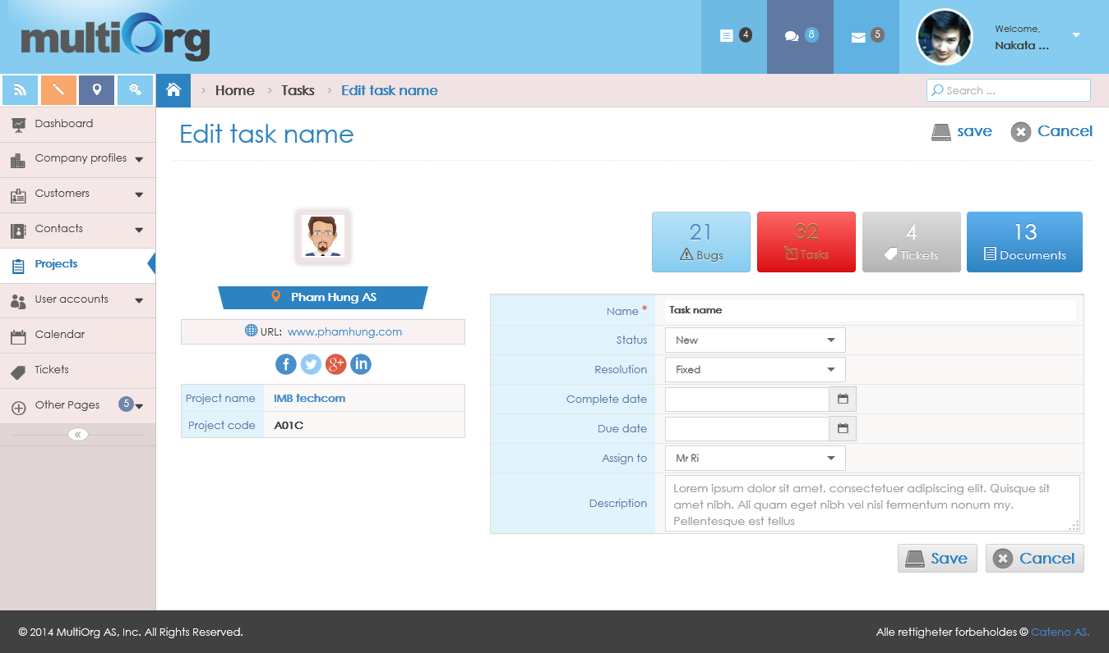

Picture: Edit task

* Use changes some fields for editing task.
* If user isn’t input the required fields, the system will show validation with the message: “* Required”.
* If user chooses Started Date, Completed Date, and Due Date with no format with date time, the system will show validation with the message: “Please enter a date in the format!”.
* If user clicks “Cancel” button, the system will disable fields that has “Edit” and “Back” button.
* If user clicks “Save” button, the system will save the data information to database and shows the message box: “Data were saved successfully!”.

#### Delete task

**Purpose**: support to delete task belongs to project.

**Who can use this**: only user who created the task.

**Description**:

* User clicks “Tasks” button in “Projects”.
* The system highlights “Tasks” button with “Red” color.
* The system shows list of tasks on grid.

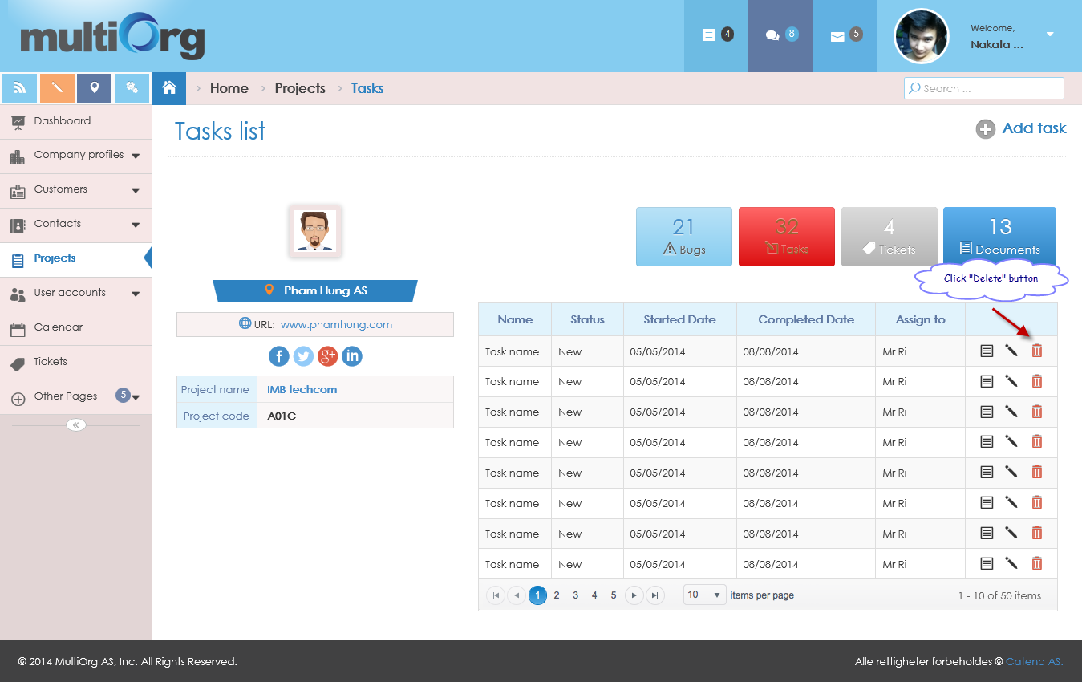

Picture: List of tasks

* User clicks “Delete” button on grid.
* The system shows the message box: “Do you want to delete this data?”.
* If user clicks “No” button, the system won’t delete task and returns to list of tasks.
* If user clicks “Yes” button, the system will delete task and returns to list of updated tasks.

#### Search task

**Purpose**: support to search task belongs to project.

**Who can use this**: user.

**Description**:

* User clicks “Tasks” button in “Projects”.
* The system highlights “Tasks” button with “Red” color.
* The system shows list of tasks on grid.
* User inputs data with condition fields of task or chooses data from list showing to search.
* The system shows list of search tasks based on conditions.

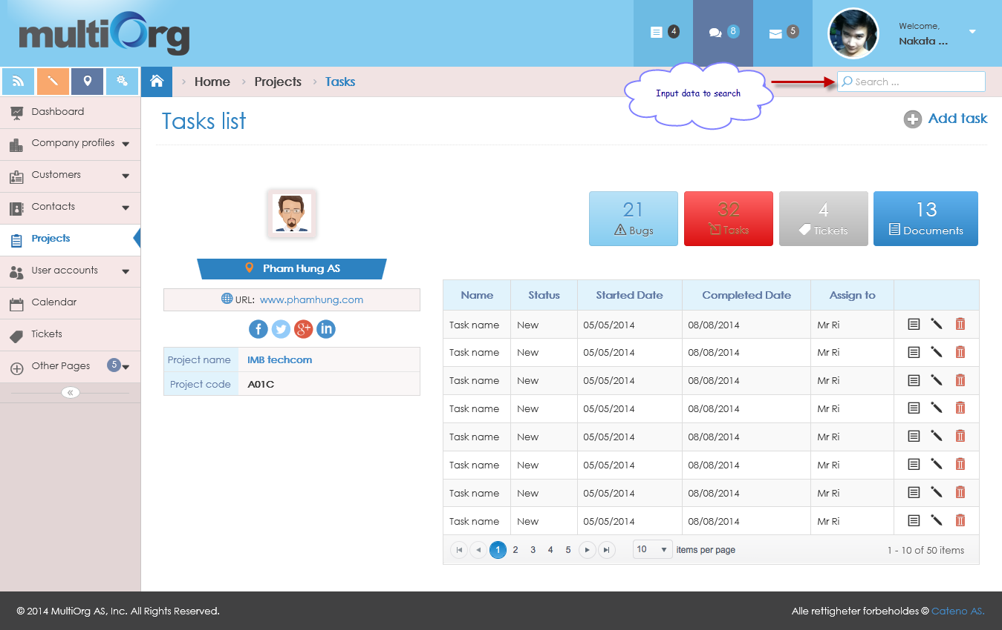

Picture: Search task

### Manage bugs

#### List of bugs

**Purpose**: support to show list of bugs belong to project.

**Who can use this**: user.

**Description**:

* User clicks “Bugs” button in “Projects”.
* The system highlights “Bugs” button with “Red” color.
* The system shows list of bugs on grid.

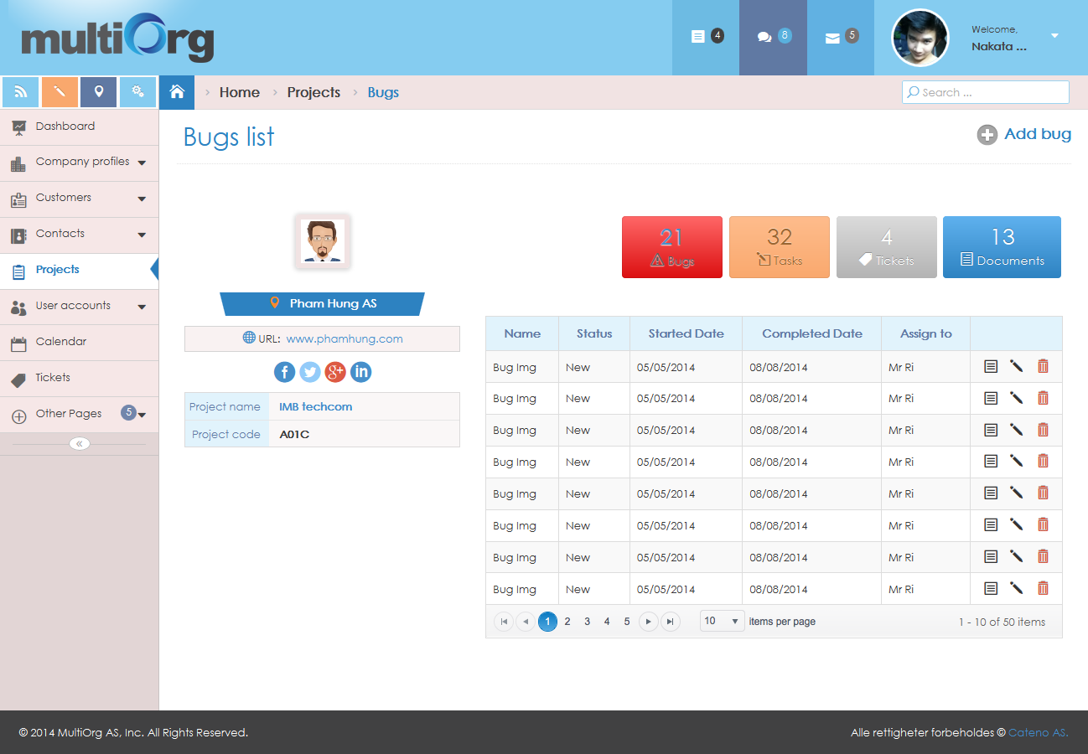

Picture: List of bugs

#### View bug detail

**Purpose**: support to view bug belongs to project.

**Who can use this**: user.

**Description**:

* User clicks “Bugs” button in “Projects”.
* The system highlights “Bugs” button with “Red” color.
* The system shows list of bugs on grid.
* User clicks “View” button on grid.

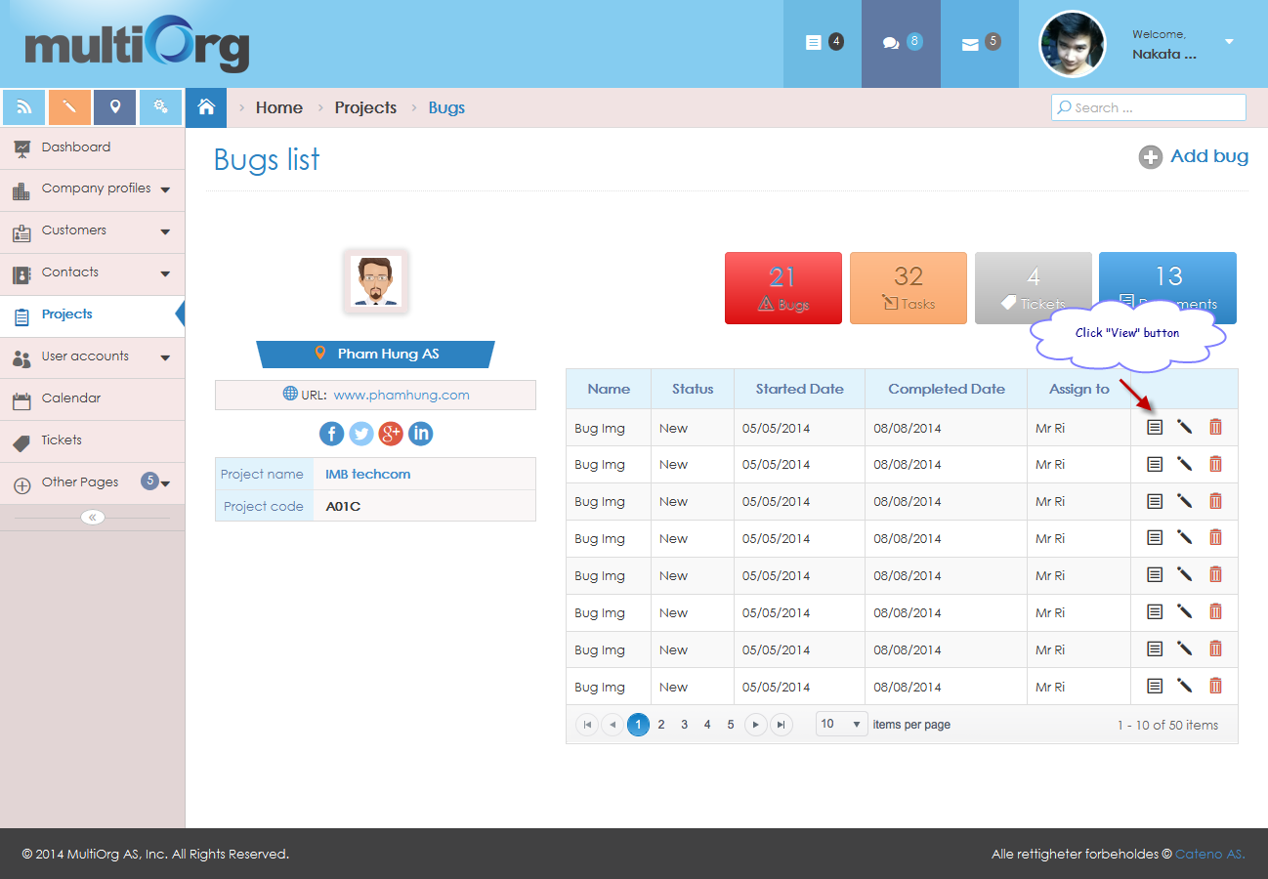

Picture: List of bugs

* The system shows bug detail belongs to project.

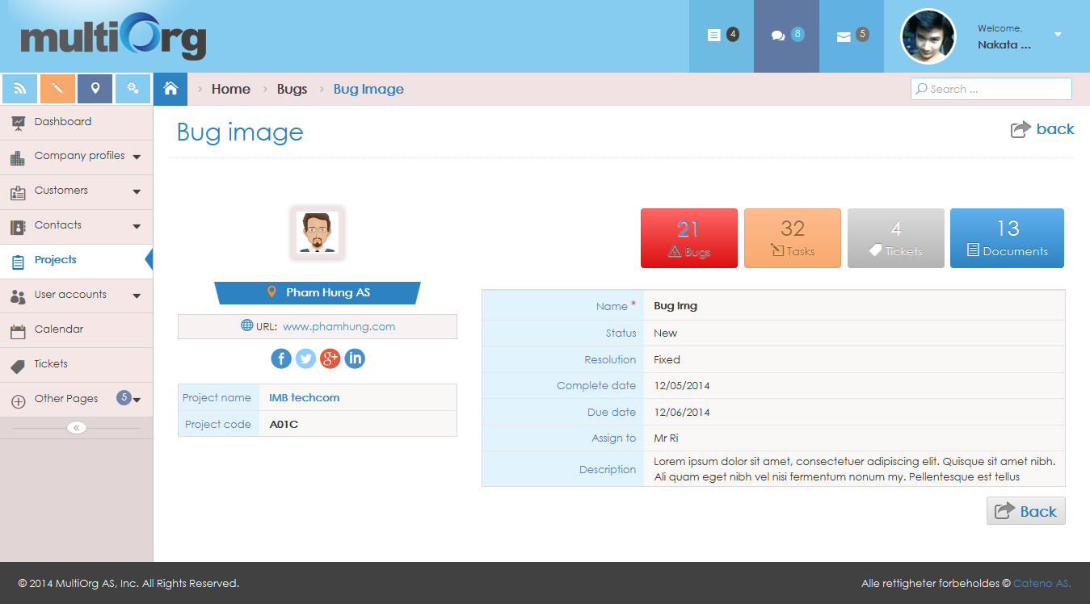

Picture: View bug detail

#### Add bug

**Purpose**: support to add bug belongs to project.

**Who can use this**: user.

**Description**:

* User clicks “Bugs” button in “Projects”.
* The system highlights “Bugs” button with “Red” color.
* The system shows list of bugs on grid.
* User clicks “Add bug” button.
* The system shows the add bug page.
* User inputs some fields for adding bug.
* If user isn’t input the required fields, the system will show validation with the message: “* Required”.
* If user chooses Started Date, Completed Date, and Due Date with no format with date time, the system will show validation with the message: “Please enter a date in the format!”.
* If user clicks “Cancel” button, the system will return to list of bugs.
* If user clicks “Save” button, the system will save data of bug to database and shows the message box: “Data were saved successfully!”.

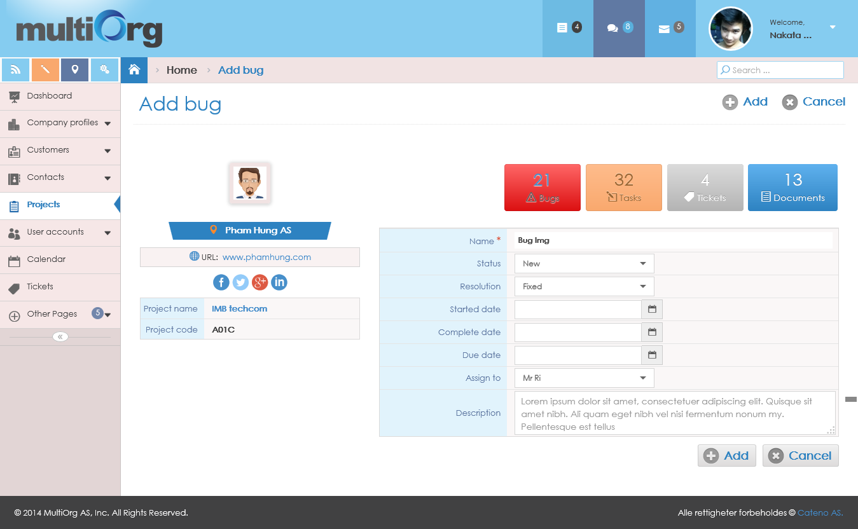

Picture: Add bug

#### Edit bug

**Purpose**: support to edit bug belongs to project.

**Who can use this**: user.

**Description**:

* User clicks “Bugs” button in “Projects”.
* The system highlights “Bugs” button with “Red” color.
* The system shows list of bugs on grid.
* User clicks “View” button on grid.



Picture: List of bugs

* The system shows bug detail page with disable all fields.



Picture: View bug detail

* If user clicks “Back” button on bug detail page, the system will return to list of bugs.
* If user clicks “Edit” button on bug detail page, the system will enable fields to edit bug that has “Save” and “Cancel” button.

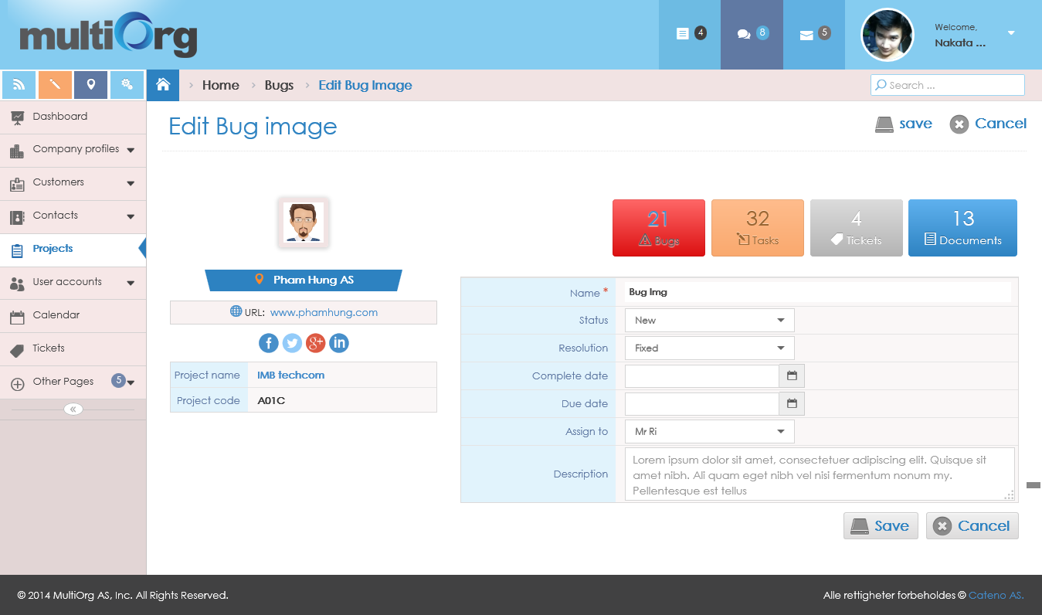

Picture: Edit bug

* User changes information of bug.
* If user isn’t input the required fields, the system will show validation with the message: “* Required”.
* If user chooses Started Date, Completed Date, and Due Date with no format with date time, the system will show validation with the message: “Please enter a date in the format!”.
* If user clicks “Cancel” button, the system will disable fields that has “Edit” and “Back” button.
* If user clicks “Save” button, the system will save the data information to database and shows the message box: “Data were saved successfully!”.

#### Delete bug

**Purpose**: support to delete bug belongs to project.

**Who can use this**: only user who created the bug.

**Description**:

* User clicks “Bugs” button in “Projects”.
* The system highlights “Bugs” button with “Red” color.
* The system shows list of bugs on grid.

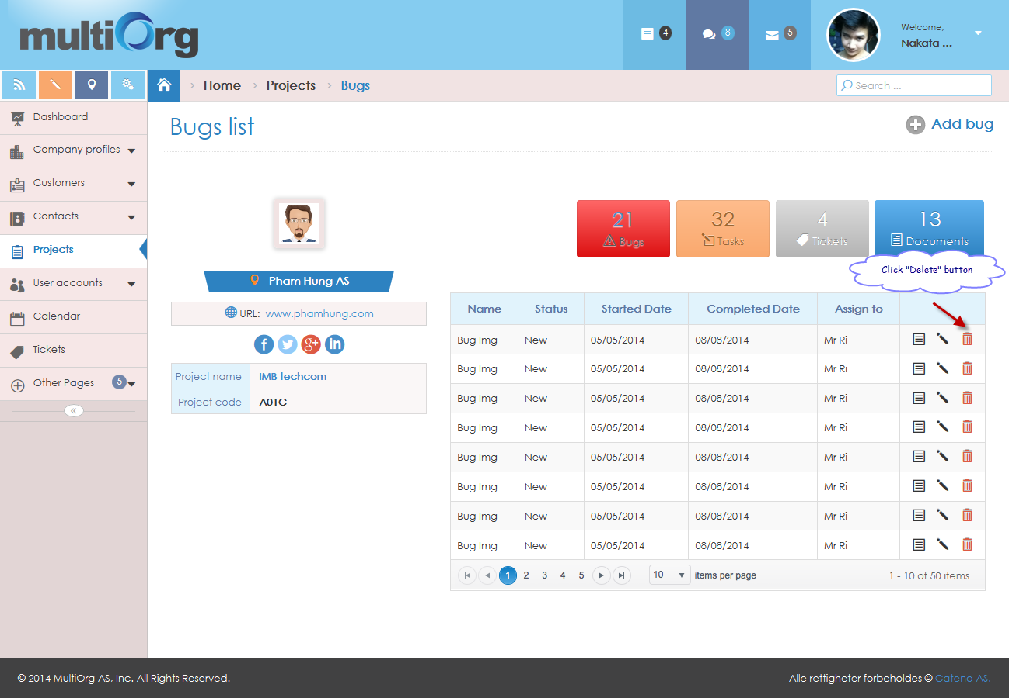

Picture: List of bugs

* User clicks “Delete” button on grid.
* The system shows the message box: “Do you want to delete this data?”.
* If user clicks “No” button, the system won’t delete bug and returns to list of bugs.
* If user clicks “Yes” button, the system will delete bug and returns to list of updated bug.

#### Search bug

**Purpose**: support to search bug belongs to project.

**Who can use this**: user.

**Description**:

* User clicks “Bugs” button in “Projects”.
* The system highlights “Bugs” button with “Red” color.
* The system shows list of bugs on grid.
* User inputs data with condition fields of bug or chooses data from list showing to search.
* The system shows list of search bugs based on conditions.

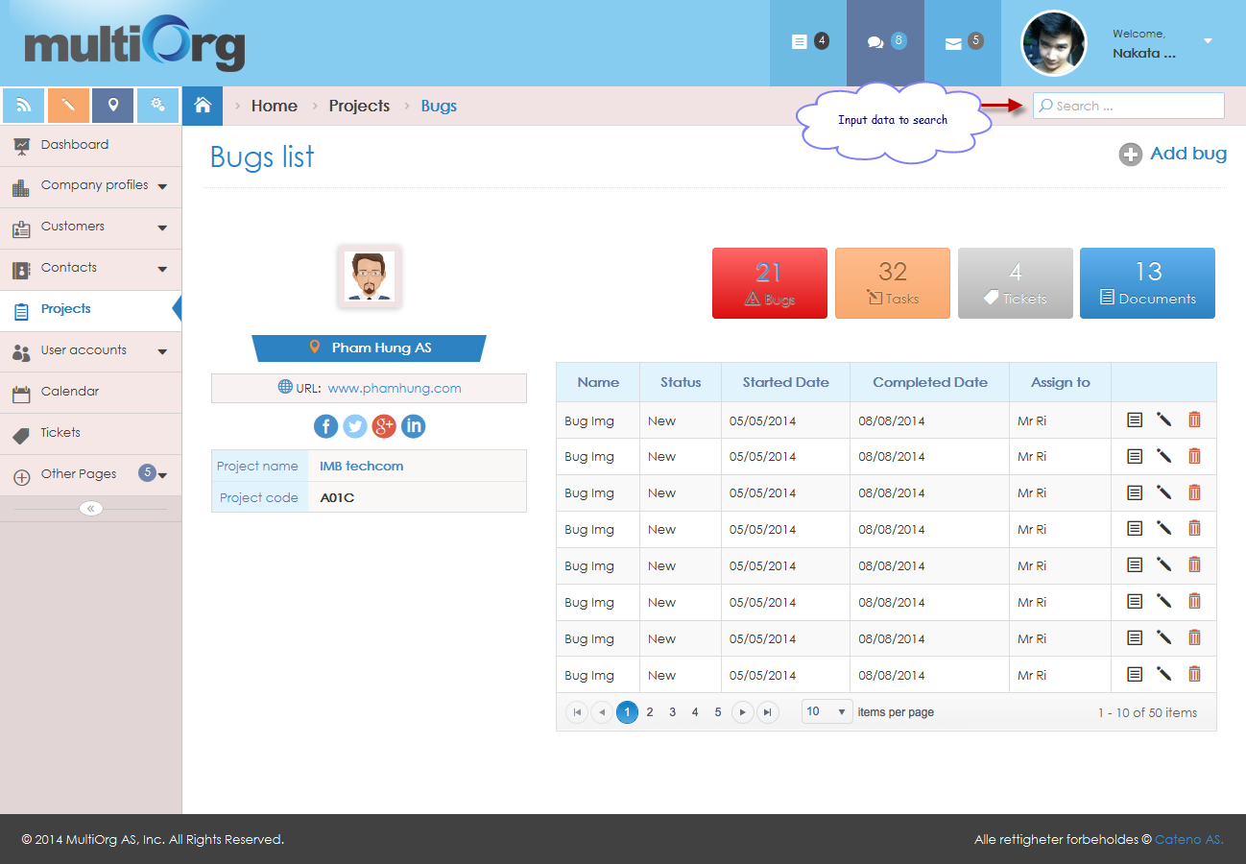

Picture: Search bug

### Manage tickets

#### List of tickets

**Purpose**: support to show list of tickets belong to project.

**Who can use this**: user.

**Description**:

* User clicks “Tickets” button in “Projects”.
* The system highlights “Tickets” button with “Red” color.
* The system shows list of tickets on grid.

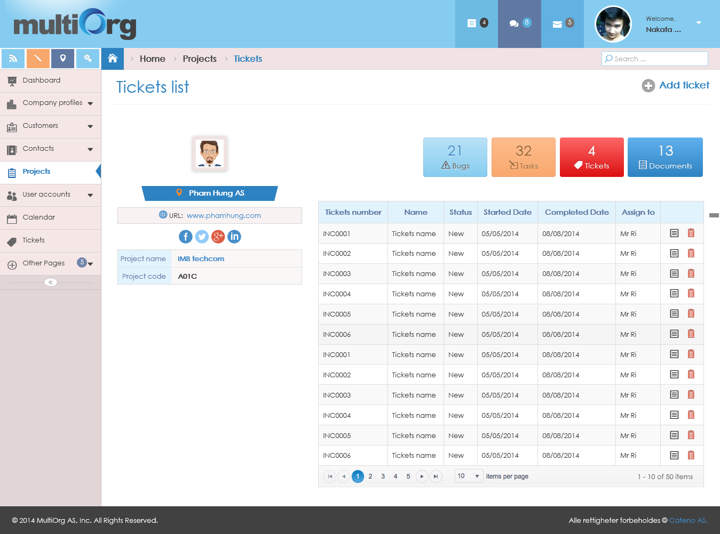

Picture: List of tickets

#### View ticket detail

**Purpose**: support to view ticket belongs to project.

**Who can use this**: user.

**Description**:

* User clicks “Tickets” button in “Projects”.
* The system highlights “Tickets” button with “Red” color.
* The system shows list of tickets on grid.
* User clicks “View” button on grid.

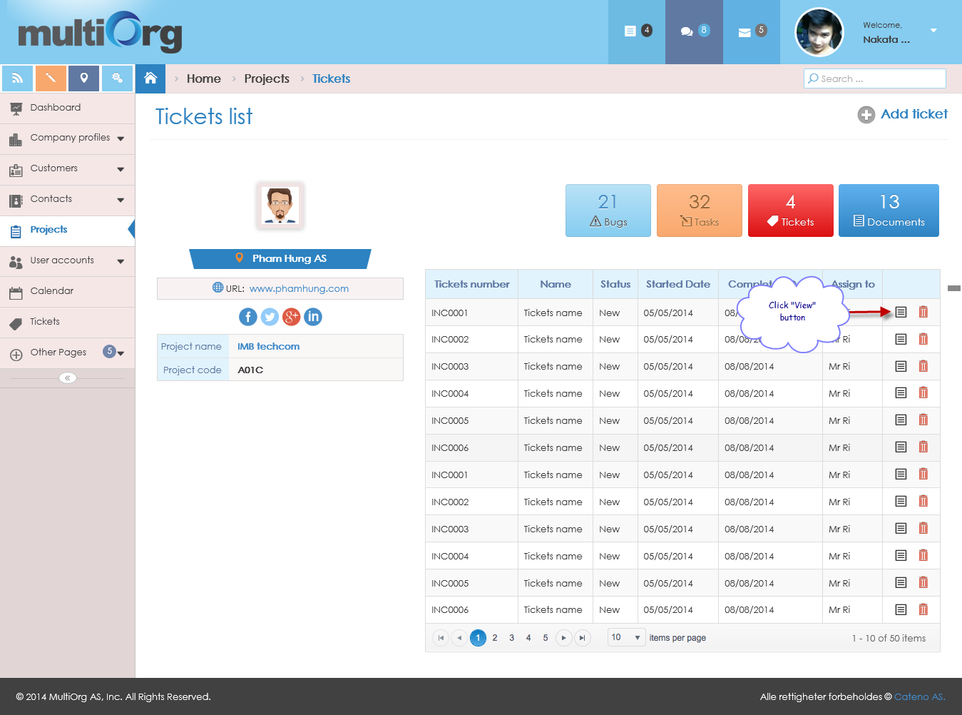

Picture: List of ticket

* The system shows ticket detail belongs to project.

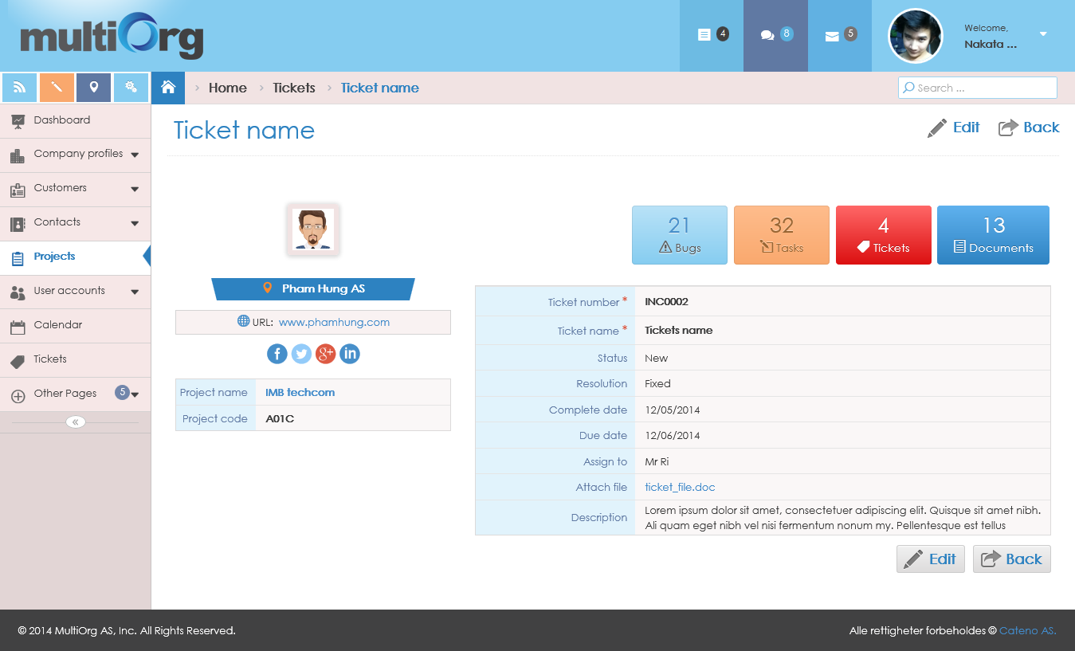

Picture: View ticket detail

#### Add ticket

**Purpose**: support to add ticket belongs to project.

**Who can use this**: user.

**Description**:

* User clicks “Tickets” button in “Projects”.
* The system highlights “Tickets” button with “Red” color.
* The system shows list of tickets on grid.
* User clicks “Add ticket” button.
* The system shows the add ticket page.
* User inputs some fields for adding ticket.
* If user isn’t input the required fields, the system will show validation with the message: “* Required”.
* If user chooses Started Date, Completed Date, and Due Date with no format with date time, the system will show validation with the message: “Please enter a date in the format!”.
* If user clicks “Cancel” button, the system will return to list of tickets.
* If user clicks “Save” button, the system will save data of ticket to database and shows the message box: “Data were saved successfully!”.

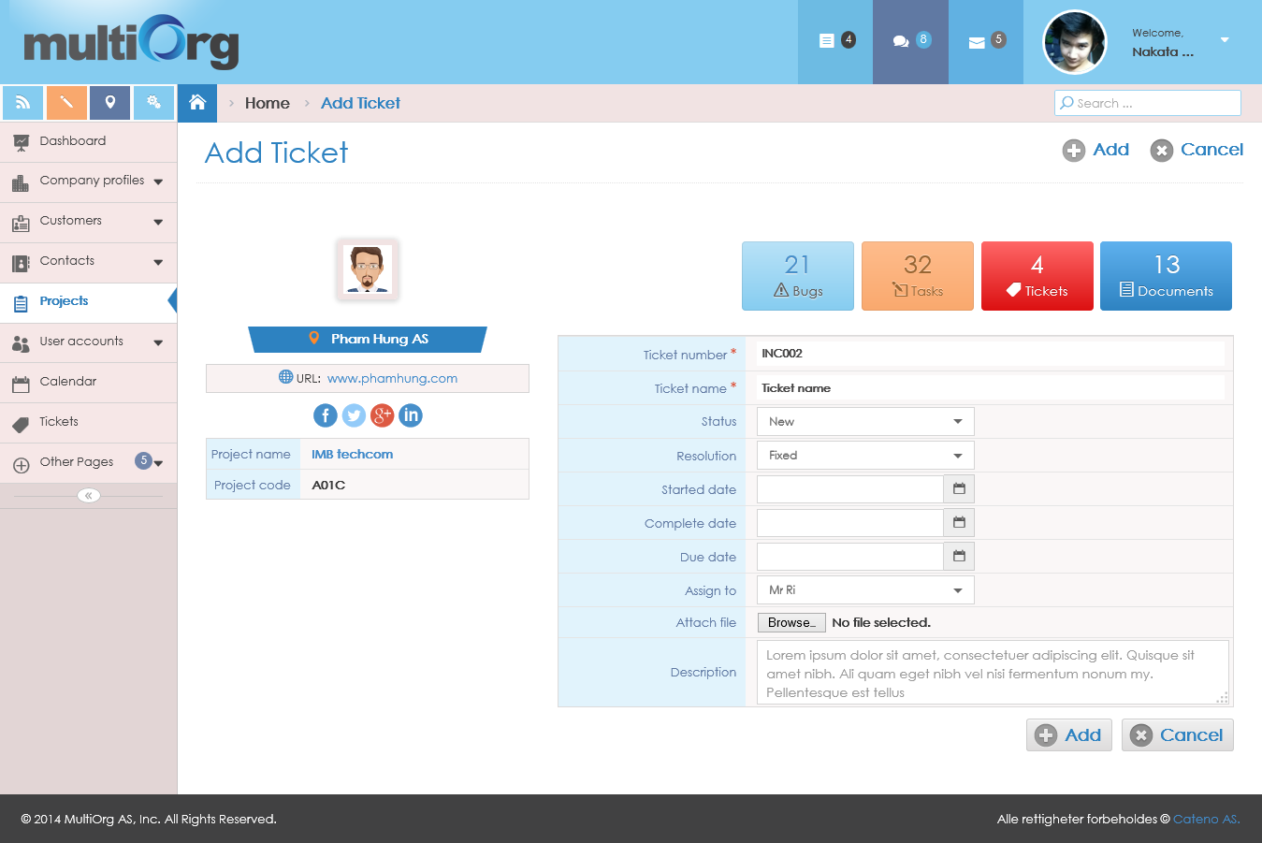

Picture: Add ticket

#### Edit ticket

**Purpose**: support to edit ticket belongs to project.

**Who can use this**: user.

**Description**:

* User clicks “Tickets” button in “Projects”.
* The system highlights “Tickets” button with “Red” color.
* The system shows list of tickets on grid.
* User clicks “View” button on grid.



Picture: List of tickets

* The system shows ticket detail page with disable all fields.



Picture: View ticket detail

* If user clicks “Back” button on ticket detail page, the system will return to list of tickets.
* If user clicks “Edit” button on ticket detail page, the system will enable fields to edit ticket that has “Save” and “Cancel” button.

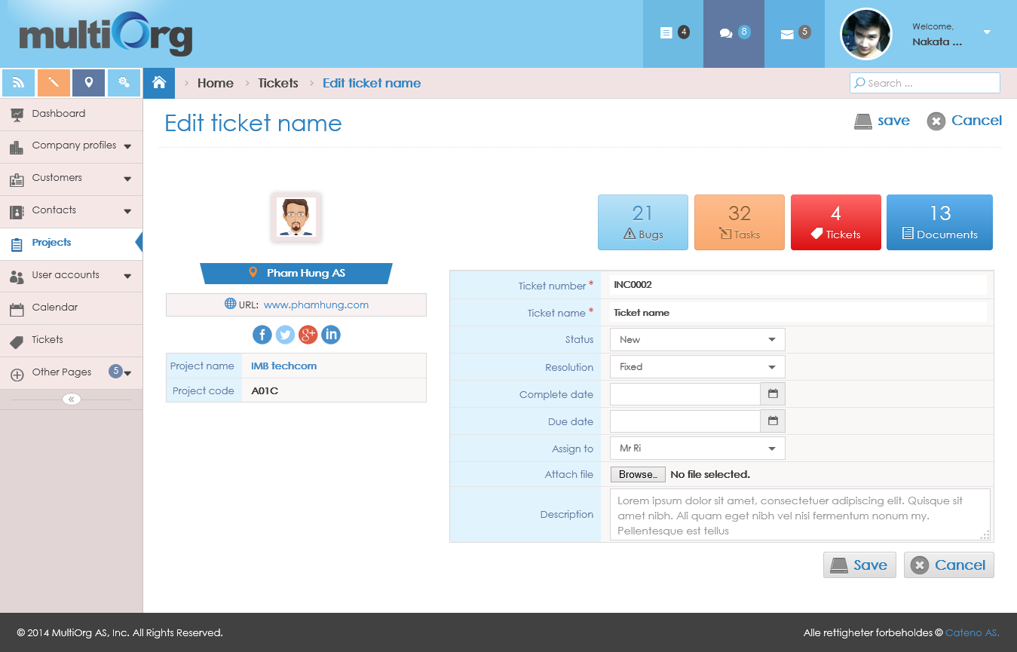

Picture: Edit ticket

* User changes information of ticket.
* If user isn’t input the required fields, the system will show validation with the message: “* Required”.
* If user chooses Started Date, Completed Date, and Due Date with no format with date time, the system will show validation with the message: “Please enter a date in the format!”.
* If user clicks “Cancel” button, the system will disable fields that has “Edit” and “Back” button.
* If user clicks “Save” button, the system will save the data information to database and shows the message box: “Data were saved successfully!”.

#### Delete ticket

**Purpose**: support to delete ticket belongs to project.

**Who can use this**: only user who created the ticket.

**Description**:

* User clicks “Tickets” button in “Projects”.
* The system highlights “Tickets” button with “Red” color.
* The system shows list of tickets on grid.

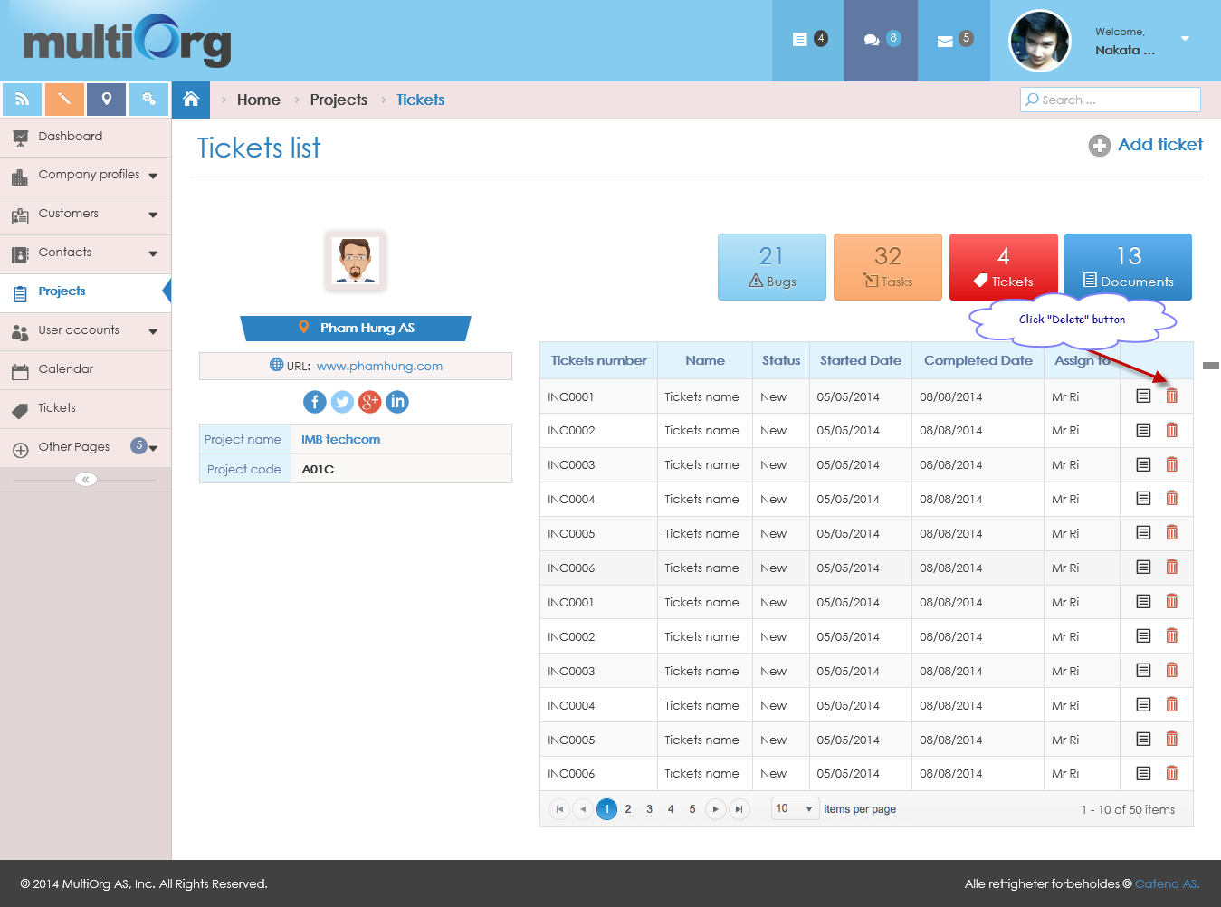

Picture: List of tickets

* User clicks “Delete” button on grid.
* The system shows the message box: “Do you want to delete this data?”.
* If user clicks “No” button, the system won’t delete ticket and returns to list of tickets.
* If user clicks “Yes” button, the system will delete ticket and returns to list of updated tickets.

#### Search ticket

**Purpose**: support to search ticket belongs to project.

**Who can use this**: user.

**Description**:

* User clicks “Tickets” button in “Projects”.
* The system highlights “Tickets” button with “Red” color.
* The system shows list of tickets on grid.
* User inputs data with condition fields of ticket or chooses data from list showing to search.
* The system shows list of search tickets based on conditions.

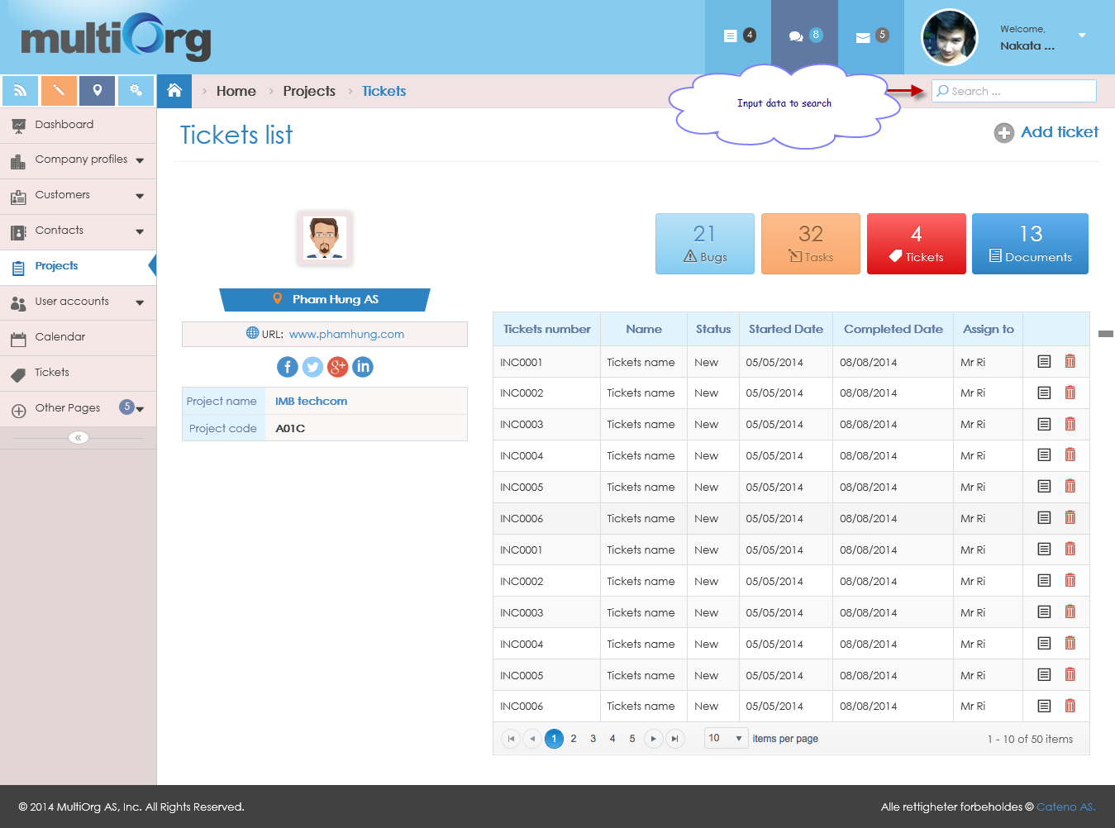

Picture: Search ticket

### Manage documents

#### List of documents

**Purpose**: support to show list of documents belong to project.

**Who can use this**: user.

**Description**:

* User clicks “Documents” button in “Projects”.
* The system highlights “Documents” button with “Red” color.
* The system shows list of documents on grid.

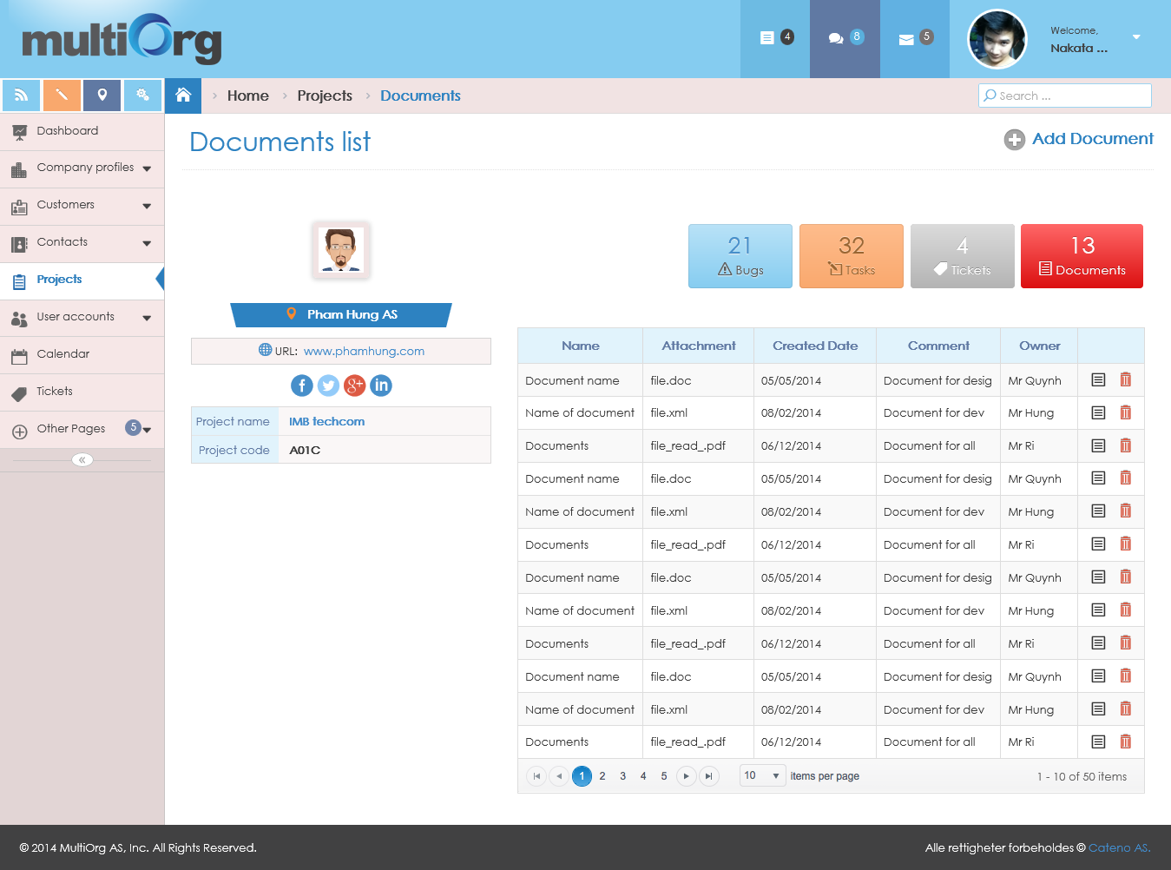

Picture: List of documents

#### View document detail

**Purpose**: support to view document belongs to project.

**Who can use this**: user.

**Description**:

* User clicks “Documents” button in “Projects”.
* The system highlights “Documents” button with “Red” color.
* The system shows list of documents on grid.
* User clicks “View” button on grid.
* The system shows document detail belongs to project.

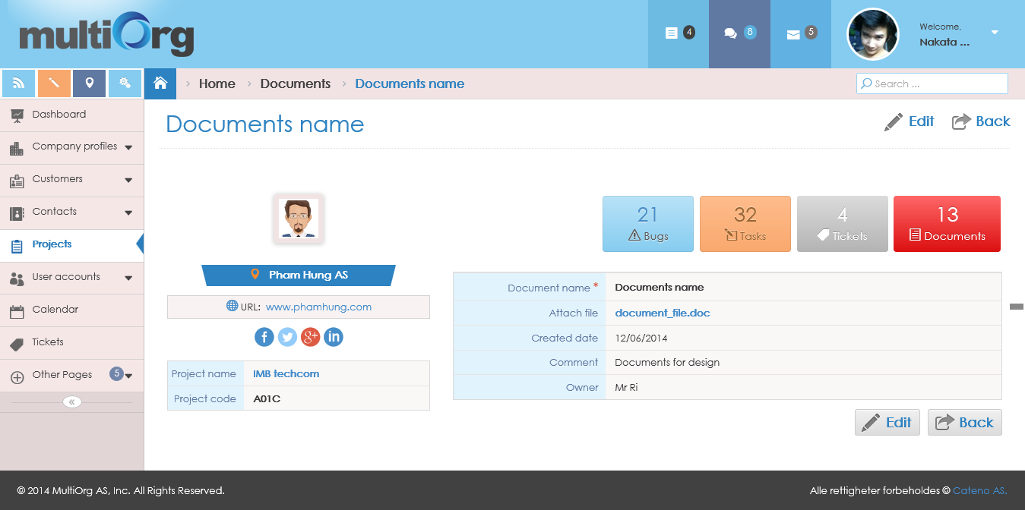

Picture: View document detail

#### Add document

**Purpose**: support to add document belongs to project.

**Who can use this**: user.

**Description**:

* User clicks “Documents” button in “Projects”.
* The system highlights “Documents” button with “Red” color.
* The system shows list of documents on grid.
* User clicks “Add document” button.
* The system shows the add document page.
* User inputs some fields for adding document.
* If user isn’t input the required fields, the system will show validation with the message: “* Required”.
* If user clicks “Cancel” button, the system will return to list of documents.
* If user clicks “Save” button, the system will save data of document to database and shows the message box: “Data were saved successfully!”.

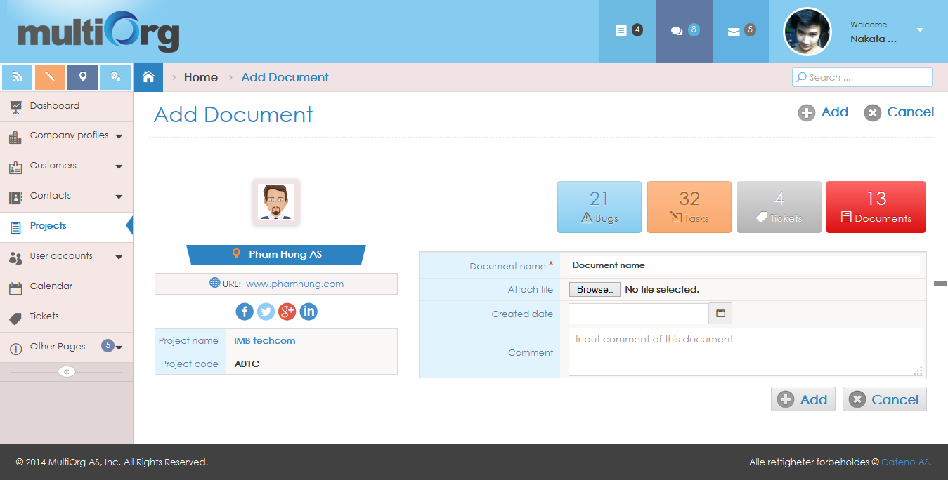

Picture: Add document

#### Edit document

**Purpose**: support to edit document belongs to project.

**Who can use this**: user.

**Description**:

* User clicks “Documents” button in “Projects”.
* The system highlights “Documents” button with “Red” color.
* The system shows list of documents on grid.
* User clicks “View” button on grid.

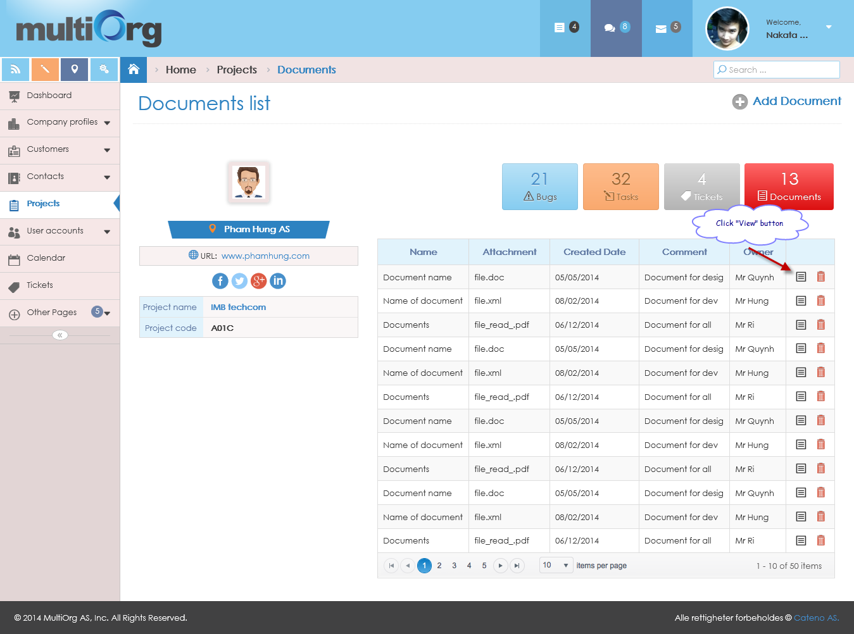

Picture: List of documents

* The system shows document detail page with disable all fields.



Picture: View document detail

* If user clicks “Back” button on document detail page, the system will return to list of documents.
* If user clicks “Edit” button on document detail page, the system will enable fields to edit document that has “Save” and “Cancel” button.

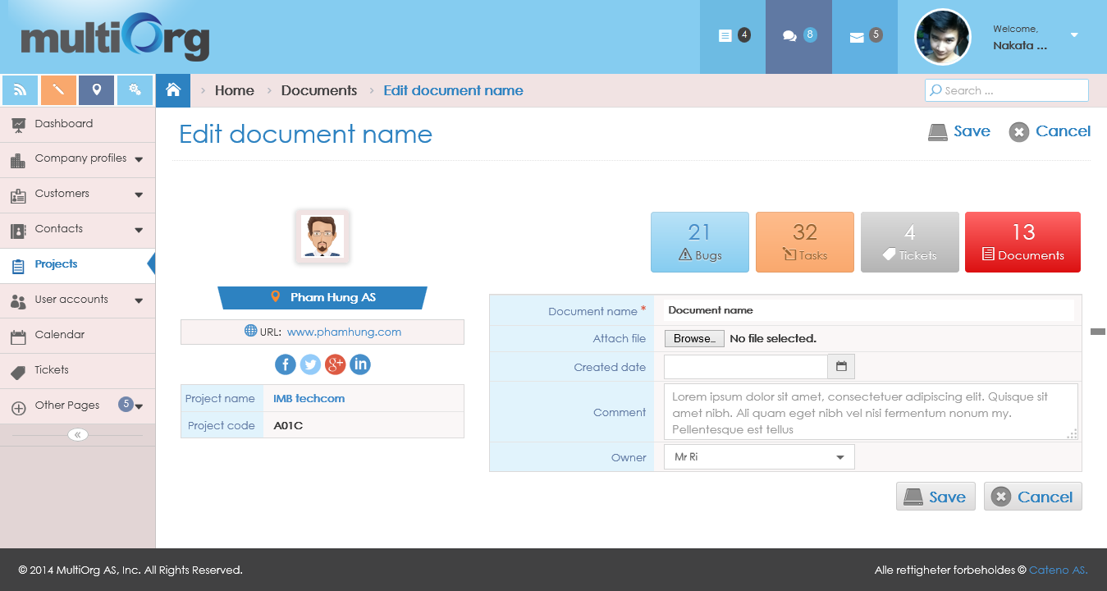

Picture: Edit document

* User changes information of document.
* If user isn’t input the required fields, the system will show validation with the message: “* Required”.
* If user clicks “Cancel” button, the system will disable fields that has “Edit” and “Back” button.
* If user clicks “Save” button, the system will save the data information to database and shows the message box: “Data were saved successfully!”.

#### Delete document

**Purpose**: support to delete document belongs to project.

**Who can use this**: only user who created the document.

**Description**:

* User clicks “Documents” button in “Projects”.
* The system highlights “Documents” button with “Red” color.
* The system shows list of documents on grid.

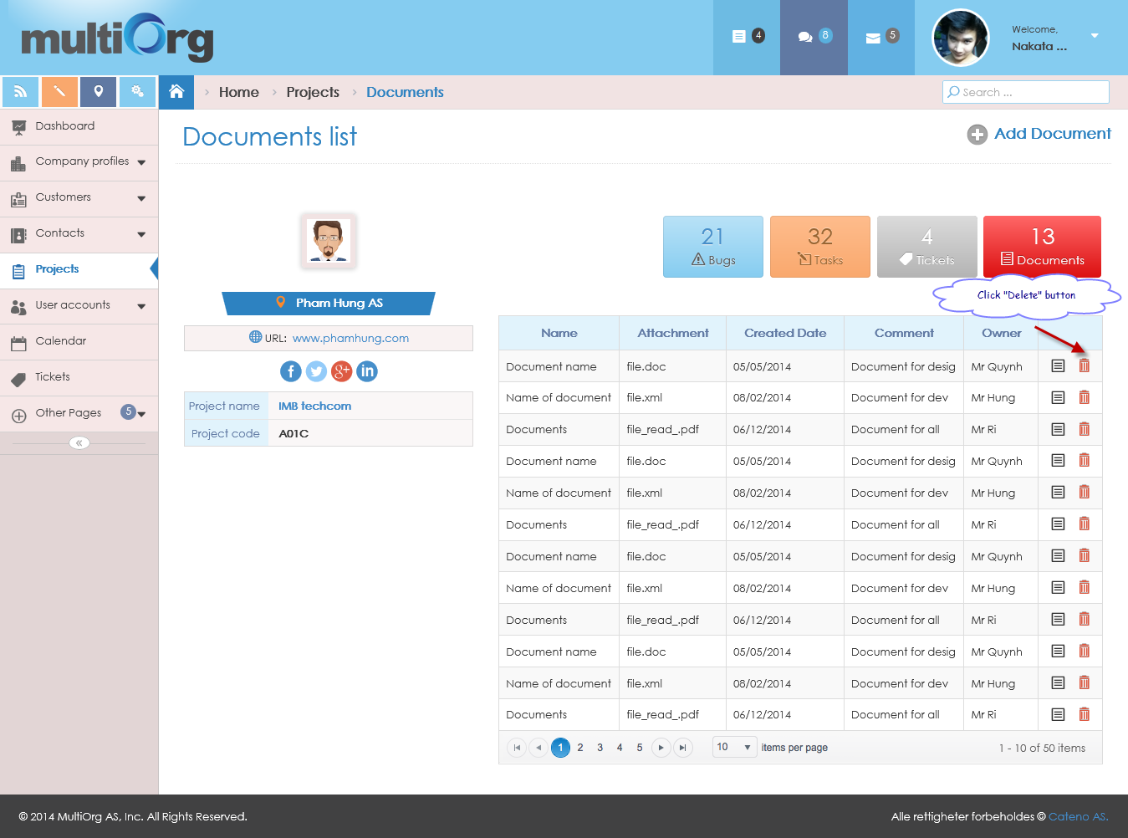

Picture: List of documents

* User clicks “Delete” button on grid.
* The system shows the message box: “Do you want to delete this data?”.
* If user clicks “No” button, the system won’t delete document and returns to list of documents.
* If user clicks “Yes” button, the system will delete document and returns to list of updated documents.

#### Search document

**Purpose**: support to search document belongs to project.

**Who can use this**: user.

**Description**:

* User clicks “Documents” button in “Projects”.
* The system highlights “Documents” button with “Red” color.
* The system shows list of documents on grid.
* User inputs data with condition fields of documents.
* User clicks “Search” button.
* The system shows list of searching documents based on conditions.

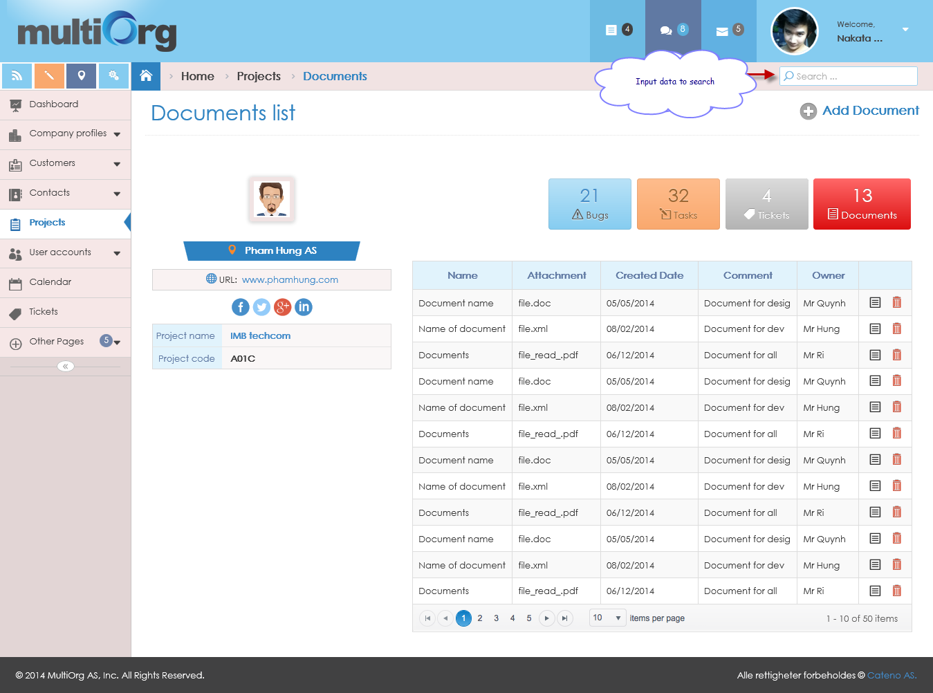

Picture: Search document